**Python for data-sciences**

Table des matières

Module 1 - Python Basics 2

Your first program 3

Types 12

Expressions and Variables 17

String Operations 23

Module 2 - Python Data Structures 32

Lists and Tuples 33

Sets 50

Dictionaries 59

Module 3 - Python Programming Fundamentals 65

Conditions and Branching 66

Loops 78

Functions 84

Object and Classes 95

Syllabus

# Module 1 - Python Basics

Your first program

Types

Expressions and Variables

String Operations

# Your first program

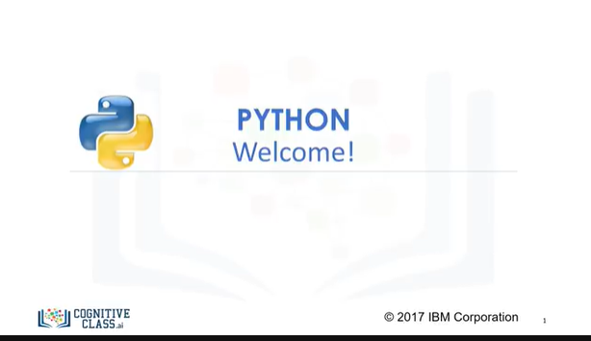

Welcome!

Welcome to Python 101 for Data Science!

In this course we’re going to cover the fundamental topics of the Python programming language.

After completing all four modules, you’ll be able to start writing your very own Python programs.

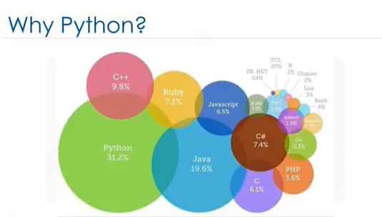

Based on recent surveys, Python was and still is the MOST popular, high-level, open-source programming language!

It is a powerful, fast and dynamic programming language that runs everywhere.

It’s also interactive, object-oriented, and very easy to learn.

Anyone can create programs with it. It’s particularly great for web development, and scientific computing.

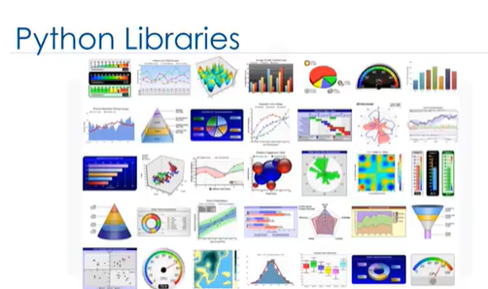

With its vast libraries, it’s also useful for data visualization and data analytics. This course covers Python 3 and its many new features. It is comprised of four modules.

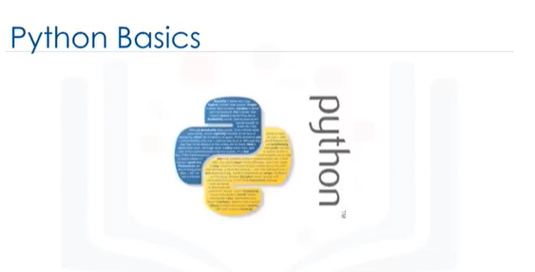

We'll start off with Python basics, writing your first program, and then cover, in detail, types, expressions, variables, strings and string operations.

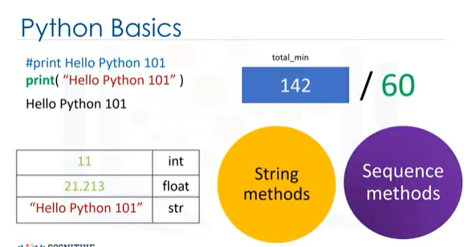

In the 2nd module we'll introduce you to Python data structures, namely lists and tuples, sets and dictionaries.

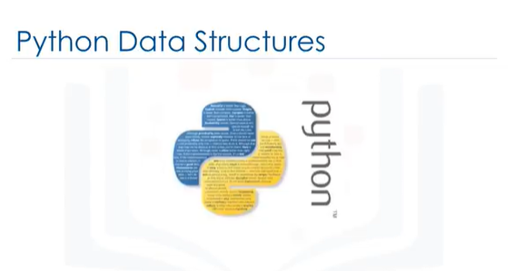

Lists and tuples, are called compound data types and are one of the key types of data

structures in Python. Sets and dictionaries are types of collections.

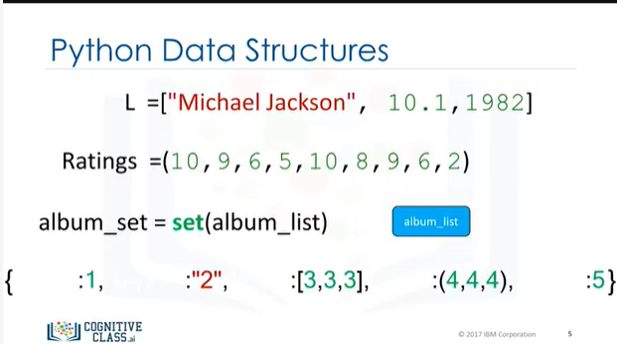

In the 3rd module we'll cover Python programming fundamentals, including conditions, branching,

loops, functions, and objects and classes.

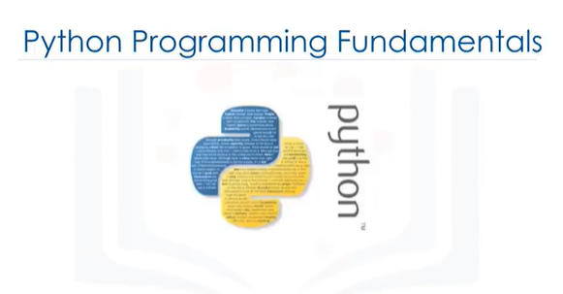

Specifically, you’ll learn about comparison and logic operators, and the if, else, and elif statements, for and while loops, how to use some of Python’s built-in functions, as well as how build your own functions, and how to create objects and classes using object constructors and attributes.

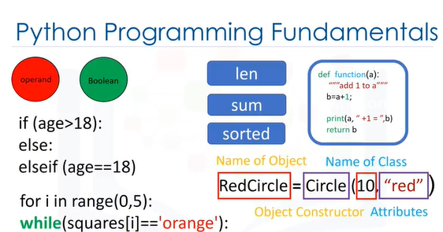

And finally, in the 4th module we'll show you how to work with data in Python.

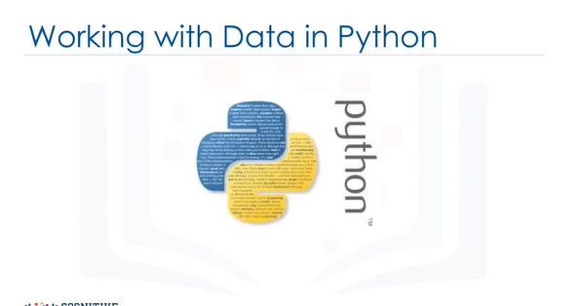

Specifically, how to read and write with the open method, and how to load, work with, and

save data in pandas. The hands-on labs after each module will have you practice what you learn, using Jupyter notebooks on Cognitive Class.ai Labs.

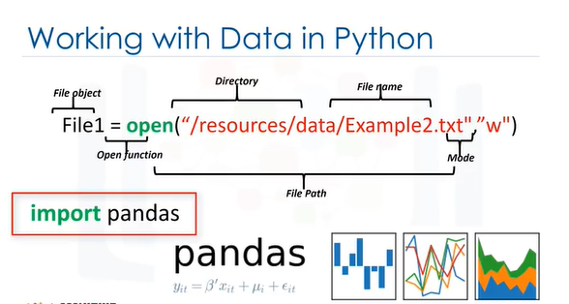

There’s a lot to go over but by practicing all these concepts you’ll be well on your way to using Python in your own applications. We’re sure you’ll be up and running with

Python in no time!

So, adjust your headphones and let’s get started!

**LEARNING OBJECTIVES**

The objectives of this course is to get you started with Python as the programming language and give you a taste of how to start working with data in Python.

In this course you will learn about:

What is Python and why is it useful

The application of Python

How to define **variables**

**Sets** and **conditional statements** in Python

The purpose of having **functions** in Python

How to operate on files to **read and write data** in Python

How to use **pandas**, a must have package for anyone attempting data analysis in Python.

**LEARNING OBJECTIVES**

In this lesson you will learn the basics of Python and you will write your first Python program:

Types

Expressions and Variables

String Operations

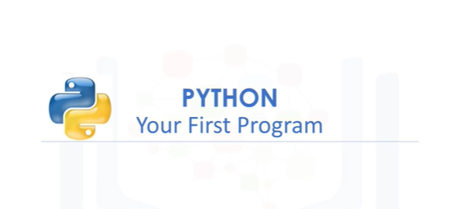

Let’s try your first program in Python. A statement or expression is an instruction the computer will run or execute.

Perhaps the simplest program you can write is a print statement.

When you run the print statement, Python will simply display the value in the parentheses.

The value in the parentheses is called theargument.

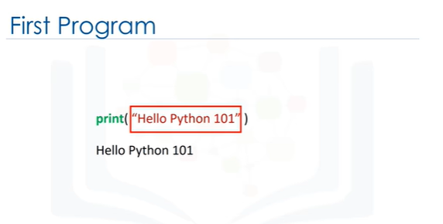

If you are using a Jupiter notebook in this course, you will see a small rectangle with the statement.

This is called a cell.

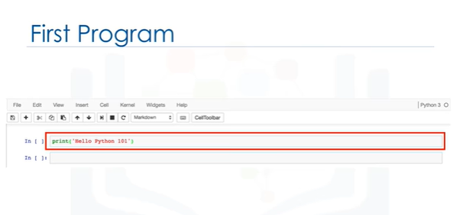

If you select this cell with your mouse, then click the run cell button.

The statement will execute.

The result will be displayed beneath the cell.

We will follow this paradigm in the videos.

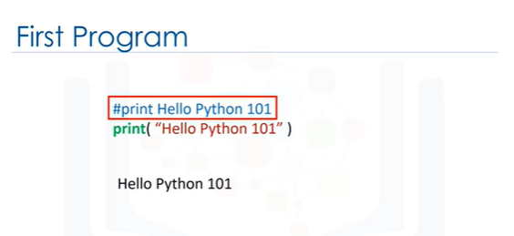

It’s customary to comment your code.

This tells other people what your code does.

You simply put a hash symbol proceeding your comment.

When you run the code, Python will ignore the comment.

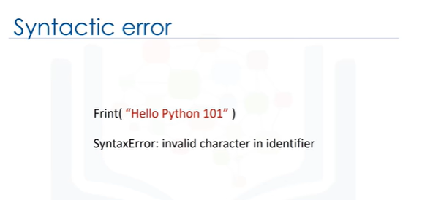

A Syntactic error is when Python does not understand your code.

For example, if you spell print "frint", you will get an error message.

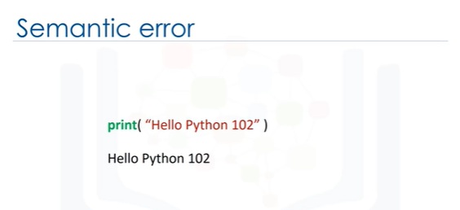

A Semantic error is when your logic is wrong.

For example, if you enter Python 102 instead of Python 101, you don't get an error message, but your code is wrong.

# Types

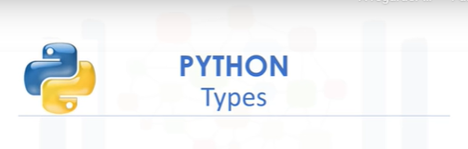

A type is how Python represents different types of data.

In this video, we will discuss some widely used types in Python.

You can have different types in Python.

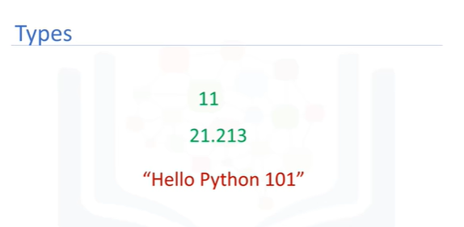

They can be integers like 11, real numbers like 21.213.

They can even be words.

Integers, real numbers and words can be expressed as different data types.

The following chart summarizes three data types for the last examples.

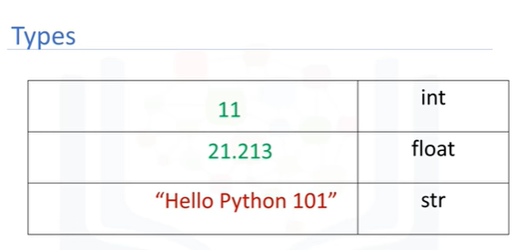

The first column indicates the expression.

The second column indicates the data type.

We can see the actual data type in Python by using the type command.

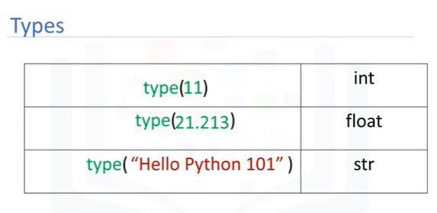

We can have int, which stands for an integer, and float that stands for float, essentially a real number.

The type string is a sequence of characters.

Here are some integers; integers can be negative or positive.

It should be noted that there is a finite range of integers, but it is quite large.

Floats are real numbers they include the integers but also numbers in between the integers.

Consider the numbers between 0 and 1.

We can select numbers in between them these numbersare floats.

Similarly, consider the numbers between 0.5 and 0.6.

We can select numbers in-between them; these are floats as well.

We can continue the process, zooming in for different numbers.

Of course, there is a limit, but it is quite small.

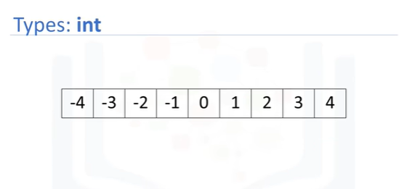

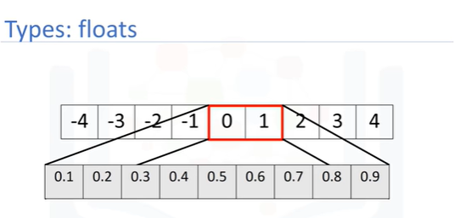

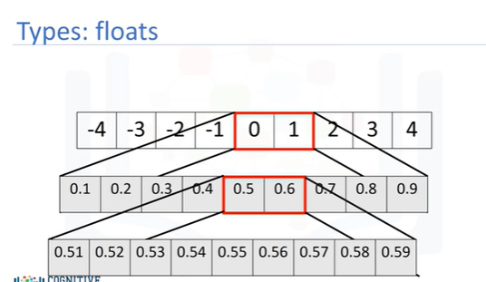

You can change the type of the expression in Python, this is called type-casting.

You can convert an int to a float.

For example, you can convert or cast the integer 2 to a float 2.

Nothing really changes.

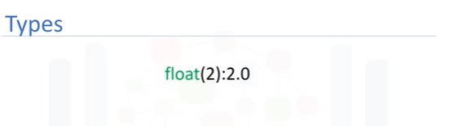

If you cast a float to an integer, you must be careful.

For example, if you cast the float 1.1 to 1, you will lose some information.

If a string contains an integer value, you can convert it to int.

If we convert a string that contains a non-integer value, we get an error.

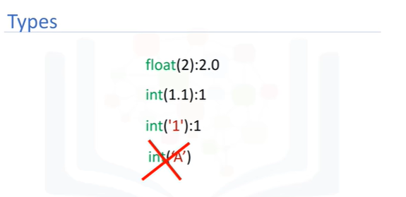

Checkout more examples in the lab.

You can convert an int to a string or a float to a string.

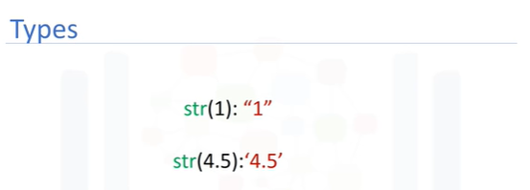

Boolean is another important type in Python.

A Boolean can take on two values.

The first value is true, just remember we use an uppercase T.

Boolean values can also be false, with an uppercase F.

Using the type command on a Boolean value, we obtain the term bool, this is short for Boolean.

If we cast a Boolean true to an integer or float, we will get a 1.

If we cast a Boolean false to an integer or float, we get a zero.

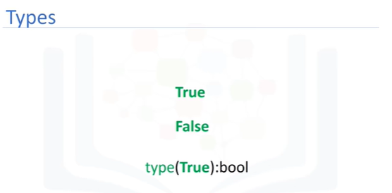

If you cast a 1 to a Boolean, you get a true.

Similarly, if you cast a 0 to a Boolean, you get a false.

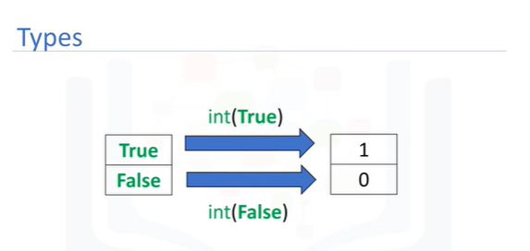

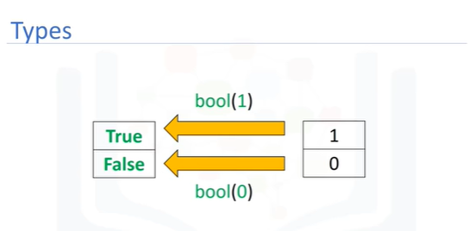

Check the labs for more examples or check Python.org for other kinds of types in Python.

# Expressions and Variables

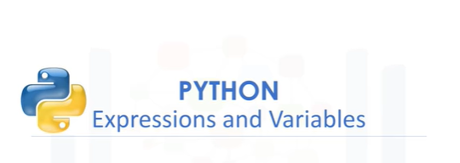

In this video we’ll cover expressions and variables.

Expressions describe a type of operation that computers perform.

Expressions are operations that Python performs. For example, basic arithmetic operations like adding multiple numbers.

The result, in this case, is 160.

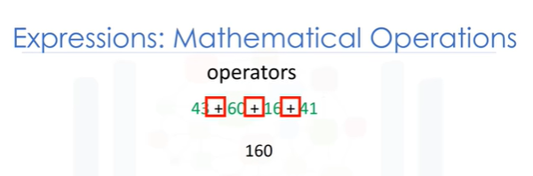

We call the numbers operands and the maths symbols, in this case addition, are called operators.

We can perform operations such as subtraction using the subtraction sign.

In this case, the result is a negative number.

We can perform multiplication operations using the asterisk.

The result is 25.

In this case the operands are given by – and *.

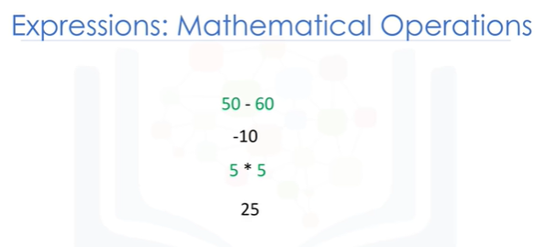

We can also perform division with the forward slash.

25 divided by 5 is 5. 25 divided by 6 is approximately 4.167.

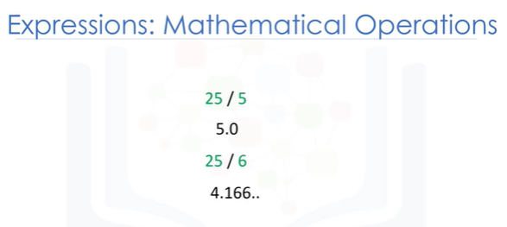

In Python 3, the version we will be using in this course, both will result in a float.

We can use the double slash for integer division, where the result is rounded.

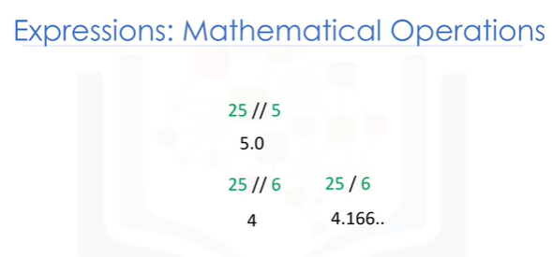

Be aware, in some cases, the results are not the same as regular division.

Python follows mathematical conventions when performing mathematical expressions.

The following operations are in a different order.

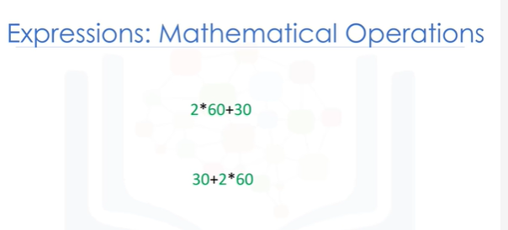

In both cases, Python performs multiplication, then addition to obtain the final result.

There are a lot more operations you can do with Python. Check the labs for more examples.

We will also be covering more complex operations throughout the course.

The expressions in the parentheses are performed first. We then multiply the result by 60, the result is 1920.

Now let’s look at variables.

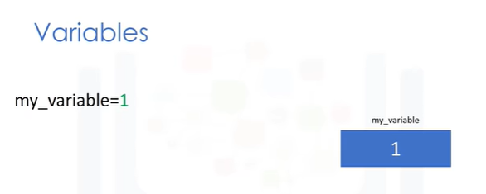

We can use variables to store values, in this case, we assign a value of 1 to the variable my_variable using the assignment operator. i.e., the equals sign.

We can then use the value somewhere else in the code by typing the exact name of the variable.

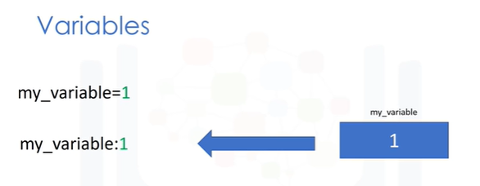

We will use a colon do denote the value of the variable.

We can assign a new value to my_variable using the assignment operator.

We assign a value of 10. The variable now has a value of 10.

The old value of the variable is not important. We can store the results of expressions, for

example, we add several values and assign the result to x.

x now stores the result. We can also perform operations on x and save the result to a new variable y. y now has a value of 2.666

We can also perform operations on x and assign the value x.

The variable x now has a value 2.666. As before, the old value of x is not important.

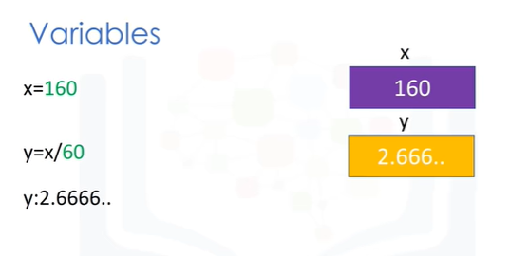

We can use the type command in variables as well.

It's good practice to use meaningful variable names, so you don't have to keep track of what the variable is doing.

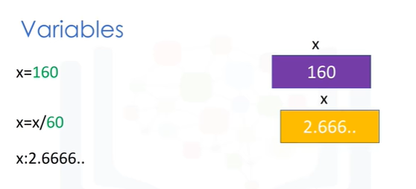

Let’s say we would like to convert the number of minutes in the highlighted examples to number of hours in the following music dataset.

We call the variable that contains the total number of minutes, total_min.

It’s common to use the underscore to represent the start of a new word, you can also use a capital letter.

We call the variable that contains the total number of hours total_hr.

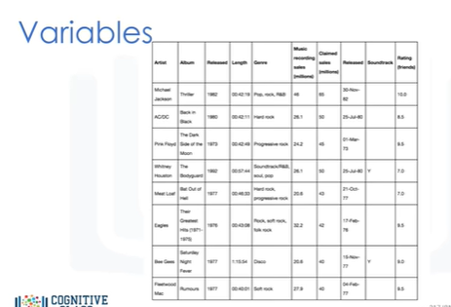

We can obtain the total number of hours by dividing total_min by 60.

The result is approximately 2.367 hours.

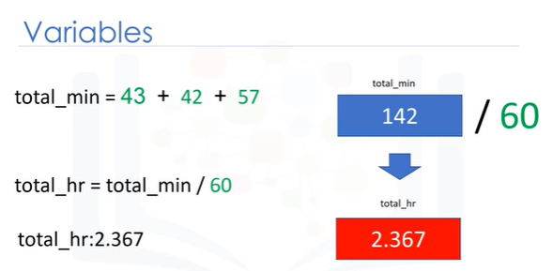

If we modify the value of the first variable, the value of the variable will change.

The final result values change accordingly, but we do not have to modify the rest of the code.

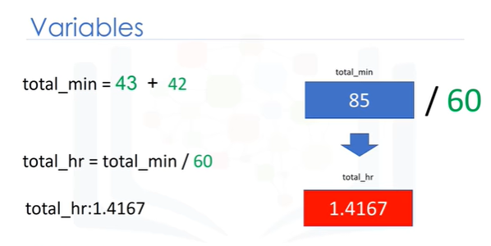

Lab Instructions

**How do I run Python?**You can use the Skills Network Labs environment to run Python code in Jupyter notebooks, by simply clicking on the "*Start Lab*" button below.

**Do I need to download or install Python?**No, you can use Python directly within your web browser, through Skills Network Labs. Just click on the "*Start Lab*" button below and Skills Network Labs will load directly on this page.

**Which version is used in these labs: Python 2 or Python 3?**All of these labs use Python 3.

**What is "**Skills Network**Labs"?**  
Skills NetworkLabs is a virtual lab environment that lets you practice what you learn in these

courses.

**What are "Jupyter Notebooks"?**  
Jupyter Notebooks are a popular data science tool that lets Data Scientists write code, see the results, and describe what's happening -- all in a single document.

# String Operations

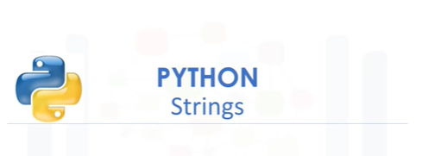

In Python, a string is a sequence of characters.

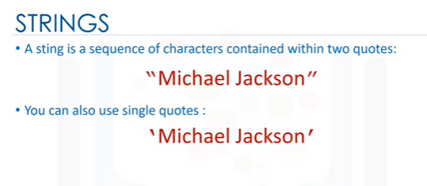

A string is contained within two quotes.

You could also use single quotes. A string can be spaces, or digits.

A string can also be special characters. We can bind or assign a string to another variable.

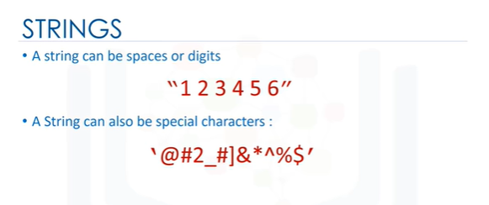

It is helpful to think of a string as an ordered sequence.

Each element in the sequence can be accessed using an index represented by the array of numbers.

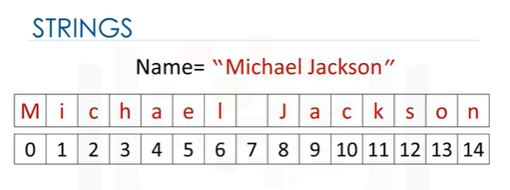

The first index can be accessed as follows.

We can access index 6.

Moreover, we can access the 13th index.

We can also use negative indexing with strings.

The last element is given by the index -1.

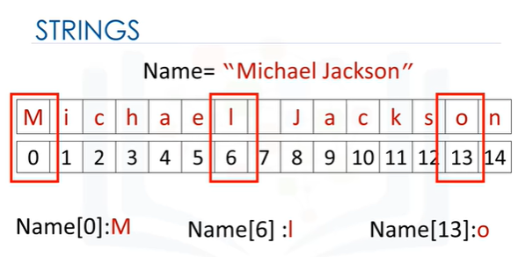

The first element can be obtained by index -15, and so on.

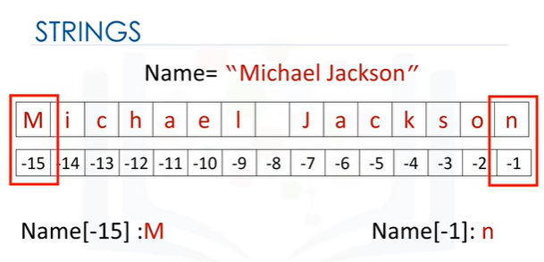

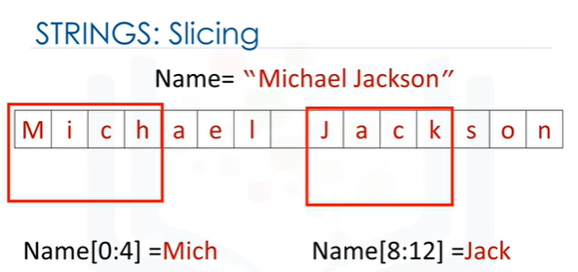

We can bind a string to another variable.

It is helpful to think of string as a list or tuple.

We can treat the string as a sequence and perform sequence operations.

We can also input a stride value as follows.

The 2 indicates we select every second variable.

We can also incorporate slicing.

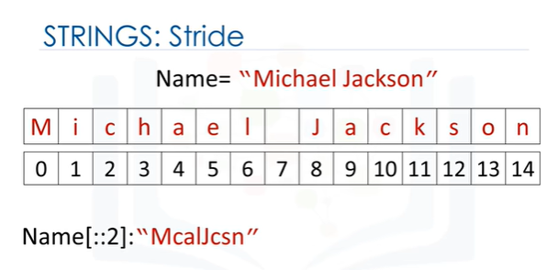

In this case, we return every second value up to index four.

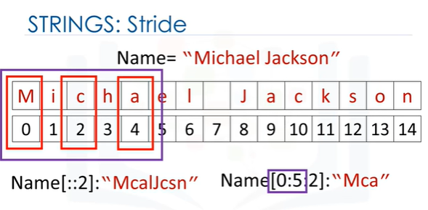

We can use the “len” command to obtain the length of the string.

As there are 15 elements, the result is 15.

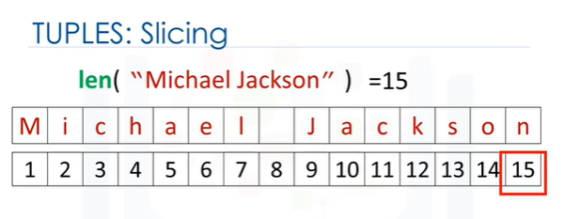

We can concatenate or combine strings. We use the addition symbols.

The result is a new string that is a combination of both.

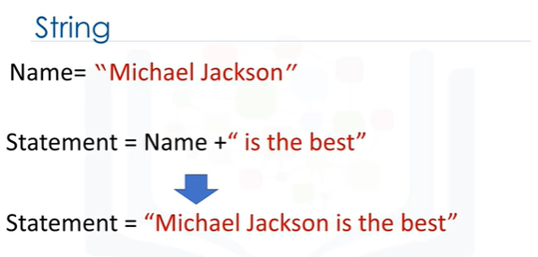

We can replicate values of a string.

We simply multiply the string by the number of times we would like to replicate it, in this case, three.

The result is a new string. The new string consists of three copies of the original string.

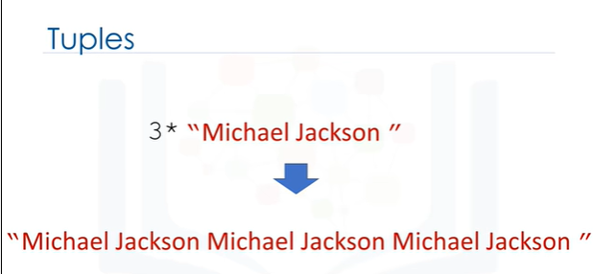

This means you cannot change the value of the string, but you can create a new string.

For example, you can create a new string by setting it to the original variable and concatenated with a new string.

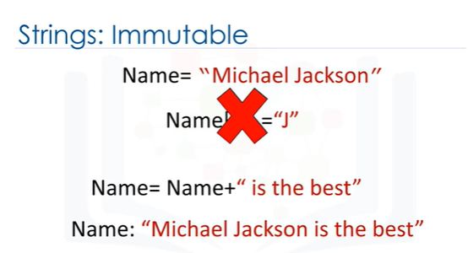

The result is a new string that changes from Michael Jackson to “Michael Jackson is the best.”

Strings are immutable.

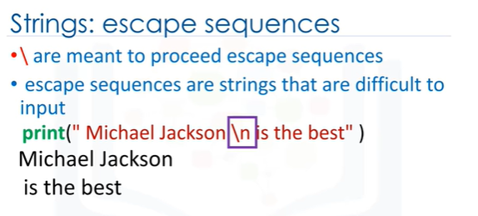

Backslashes represent the beginning of escape sequences.

Escape sequences represent strings that may be difficult to input.

For example, backslashes "n" represent a new line.

The output is given by a new line after the backslashes "n” is encountered.

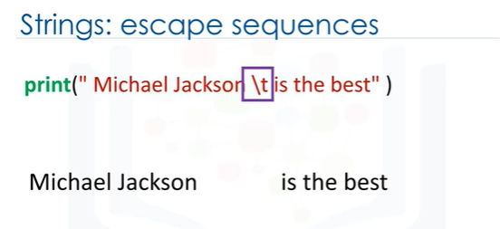

Similarly, backslash "t" represents a tab. The output is given by a tab where the backslash "t" is.

If you want to place a backslash in your string, use a double backslash.

The result is a backslash after the escape sequence.

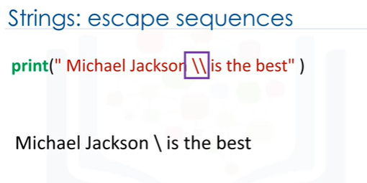

We can also place an r in front of the string.

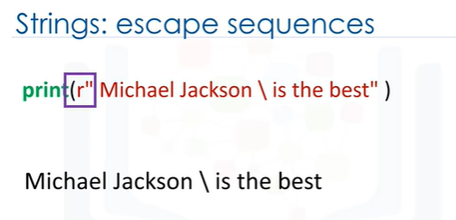

Now let’s take a look at String Methods. Strings are sequences and, as such, have apply methods that work on lists and tuples.

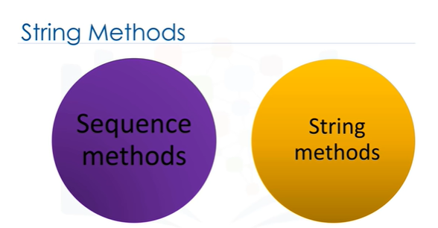

Strings also have a second set of methods that just work on strings.

When we apply a method to the string "A”, we get a new string “B" that is different from "A".

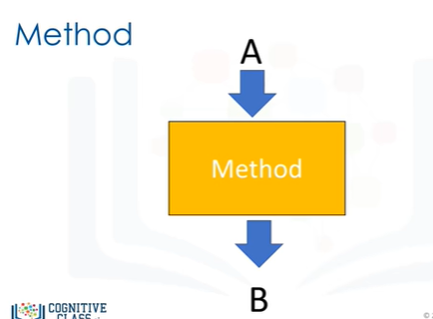

Let’s do some examples.

Let's try with the method upper.

This method converts lower case characters to upper case characters.

In this example, we set the variable A to the following value.

We apply the method "upper" and set it equal to "B“.

The value for B is similar to "A" but all the characters are uppercase.

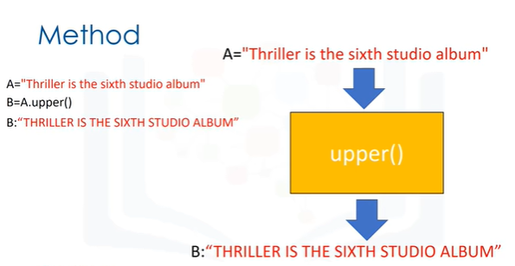

The method replaces a segment of the string, i.e., a substring with a new string.

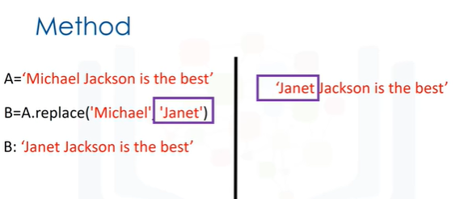

We input the part of the string we would like to change.

The second argument is what we would like to exchange the segment with.

The result is a new string with the segment changed.

The method find, finds sub-strings. The argument is the sub-string you would like to find.

The output is the first index of the sequence.

We can find the sub-string Jack. If the sub-string is not in the string, the output is negative one.

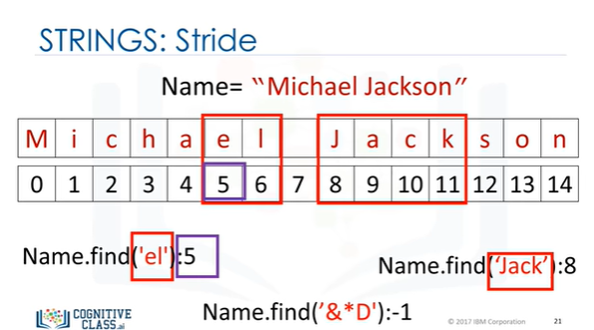

Check the labs for more examples.

# Module 2 - Python Data Structures

Lists and Tuples

Sets

Dictionaries

# Lists and Tuples

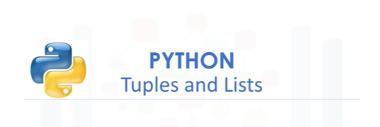

In this video, we will cover lists and tuples, these are called compound data types and are one of the key types of data structures in Python.

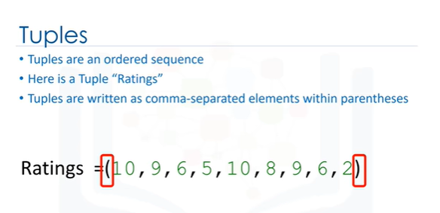

Tuples Tuples are an ordered sequence.

Here is a Tuple “Ratings.”

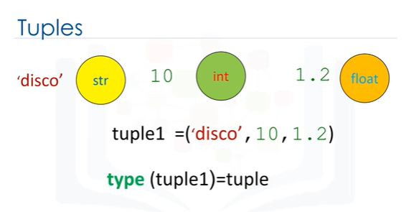

Tuples are expressed as comma-separated elements within parentheses.

These are values inside the parentheses.

In Python, there are different types: strings, integer, float.

They can all be contained in a tuple, but the type of the variable is tuple.

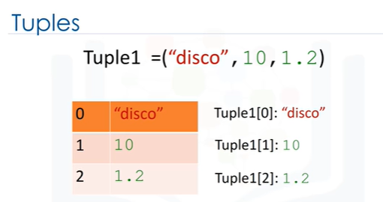

Each element of a tuple can be accessed via an index.

The following table represents the relationship between the index and the elements in the

tuple.

The first element can be accessed by the name of the tuple followed by a square bracket

with the index number, in this case, zero.

We can access the second element as follows.

We can also access the last element.

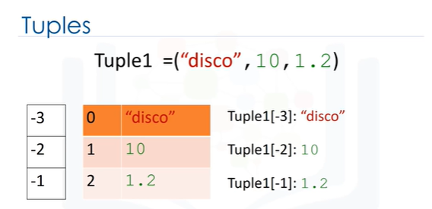

In Python, we can use negative index.

The relationship is as follows.

The corresponding values are shown here.

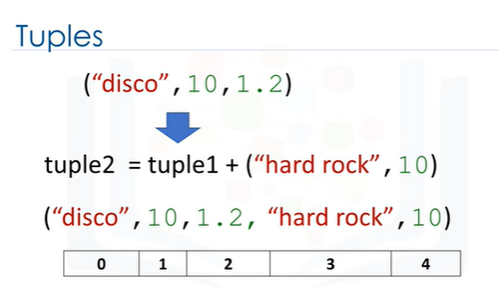

We can concatenate or combine tuples by adding them.

The result is the following with the following index.

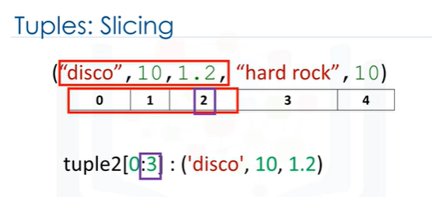

If we would like multiple elements from a tuple, we could also slice tuples.

For example, if we want the first three elements, we use the following command.

The last index is 1 larger than the index you want.

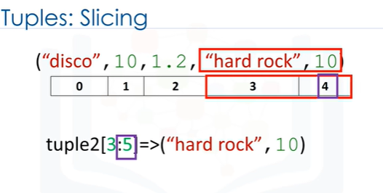

Similarly, if we want the last two elements, we use the following command.

Notice how the last index is 1 larger than the length of the tuple.

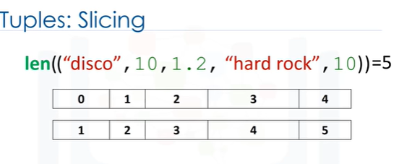

We can use the “len” command to obtain the length of a tuple.

As there are 5 elements, the result is five.

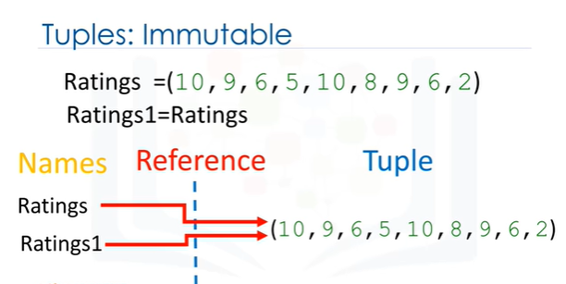

Tuples are immutable, which means we can't change them.

To see why this is important, let's see what happens when we set the variable Ratings 1

to ratings.

Let's use the image to provide a simplified explanation of what’s going on.

Each variable does not contain a tuple, but references the same immutable tuple object.

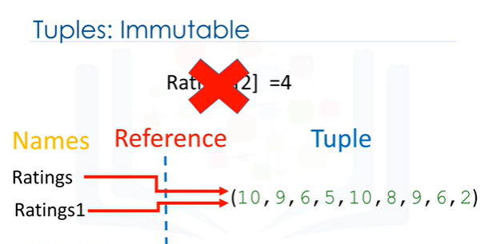

See the ‘objects and classes’ module for more about objects.

Let's say we want to change the element at index 2.

Because tuples are immutable, we can't.

Therefore, Ratings 1 will not be affected by a change in Rating because the tuple is immutable i.e., we can't change it.

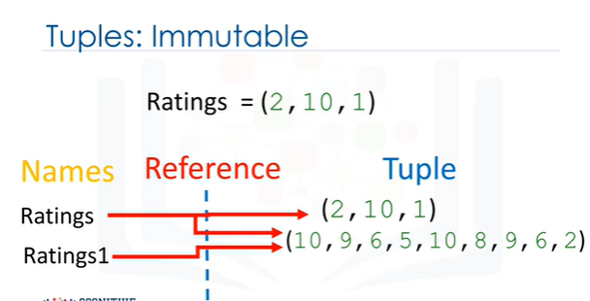

We can assign a different tuple to the Ratings variable.

The variable Ratings now references another tuple.

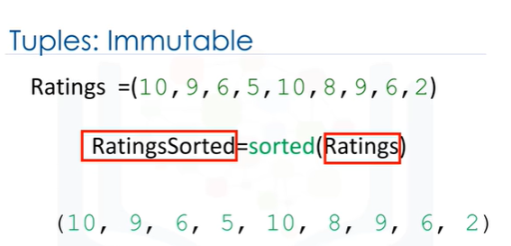

As a consequence of immutability, if we would like to manipulate a tuple, we must create a new tuple instead.

For example, if we would like to sort a tuple, we use the function sorted.

The input is the original tuple.

The output is a new sorted tuple.

For more on functions, see our video on functions.

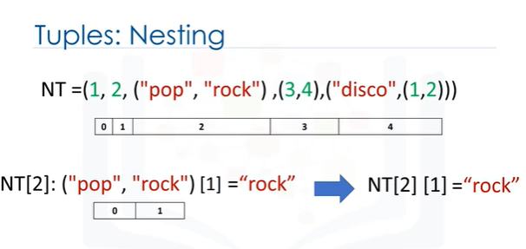

A tuple can contain other tuples as well as other complex data types; this is called nesting.

We can access these elements using the standard indexing methods.

If we select an index with a tuple, the same index convention applies.

As such, we can then access values in the tuple.

For example, we could access the second element.

We can apply this indexing directly to the tuple variable NT.

It is helpful to visualize this as a tree.

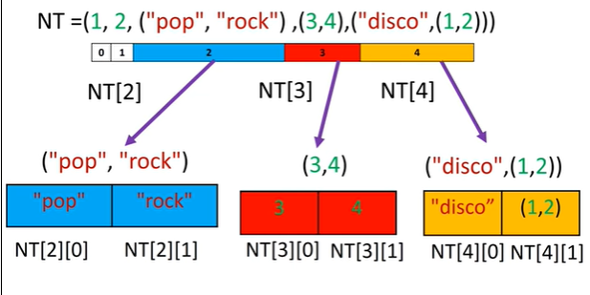

We can visualize this nesting as a tree.

The tuple has the following indexes.

If we consider indexes with other tuples, we see the tuple at index 2 contains a tuple

with two elements.

We can access those two indexes.

The same convention applies to index 3.

We can access the elements in those tuples as well.

We can continue the process.

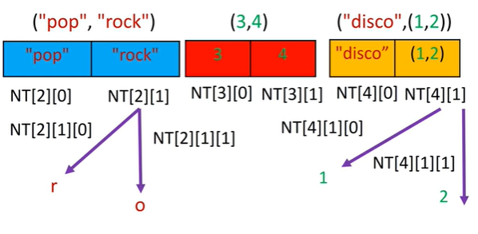

We can even access deeper levels of the tree by adding another square bracket.

We can access different characters in the string or various elements in the second tuple contained in the first.

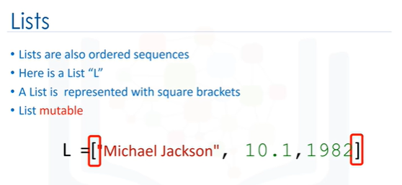

Lists are also a popular data structure in Python.

Lists are also an ordered sequence.

Here is a list L. A list is represented with square brackets.

In many respects lists are like tuples, one key difference is they are mutable.

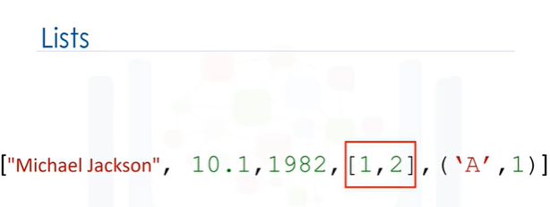

Lists can contain strings, floats, integers.

We can nest other lists.

We also nest tuples and other data structures; the same indexing conventions apply for nesting.

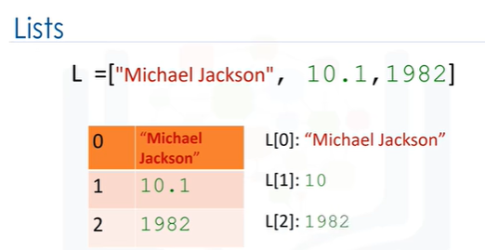

Like tuples, each element of a list can be accessed via an index.

The following table represents the relationship between the index and the elements in the

list.

The first element can be accessed by the name of the list followed by a square bracket with

the index number, in this case zero.

We can access the second element as follows.

We can also access the last element.

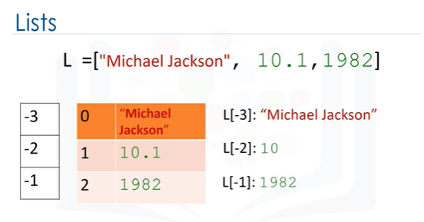

In Python, we can use a negative index.

The relationship is as follows.

The corresponding indexes are as follows.

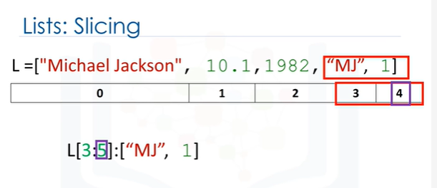

We can also perform slicing in lists.

For example, if we want the last two elements in this list we use the following command.

Notice how the last index is 1 larger than the length of the list.

The index conventions for lists and tuples are identical.

Check the labs for more examples.

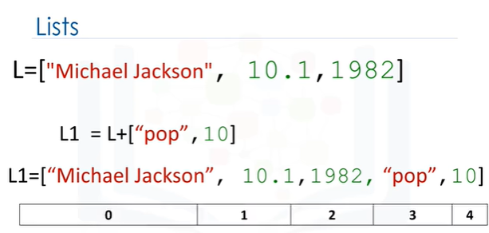

We can concatenate or combine lists by adding them.

The result is the following.

The new list has the following indices.

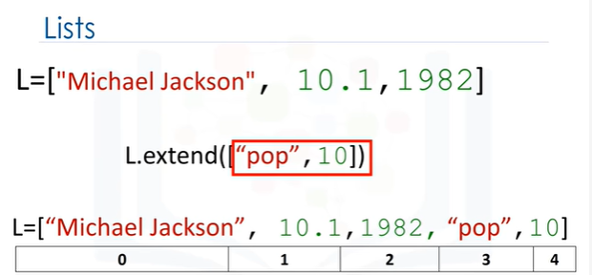

Lists are mutable, therefore, we can change them.

For example, we apply the method extends by adding a "dot" followed by the name of the method, then parenthesis.

The argument inside the parenthesis is a new list that we are going to concatenate to the original list.

In this case, instead of creating a new list, L1, the original list L is modified by adding two new elements.

To learn more about methods check out our video on objects and classes.

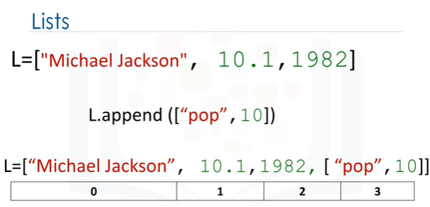

Another similar method is append.

If we apply append instead of extended we add one element to the list.

If we look at the index, there is only one more element.

Index 3 contains the list we appended.

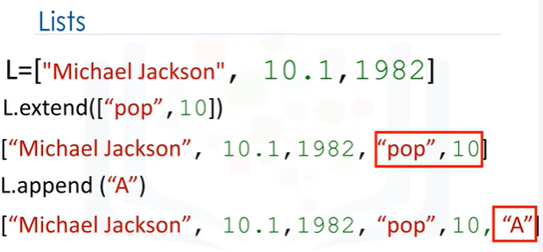

Every time we apply a method, the lists changes.

If we apply extend, we add two new elements to the list.

The list L is modified by adding two new elements.

If we append the string “A“, we further change the list adding the string “A”.

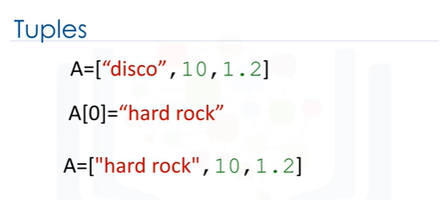

As lists are mutable, we can change them.

For example, we can change the first element as follows.

The list now becomes: “hard rock”, 10, 1.2.

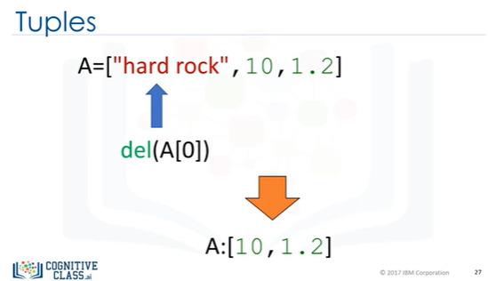

We can delete an element of a list using the "del" command; we simply indicate the list item we would like to remove as an argument.

For example, if we would like to remove the first element, the result becomes 10,1.2.

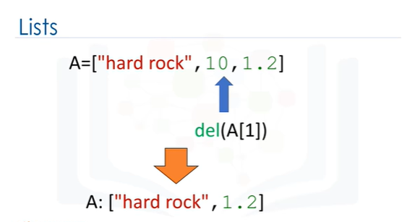

We can delete the second element.

This operation removes the second element of the list.

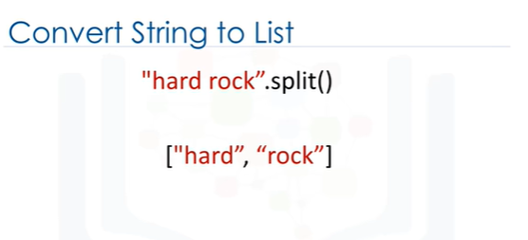

We can convert a string to a list using split.

For example, the method split converts every group of characters separated by a space into an element of a list.

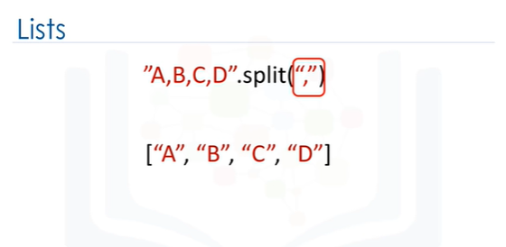

We can use the split function to separate strings on a specific character, known as a delimiter.

We simply pass the delimiter we would like to split on as an argument, in this case a comma.

The result is a list, each element corresponds to a set of characters that have been separated by a comma.

When we set one variable, B equal to A, both A and B are referencing the same list.

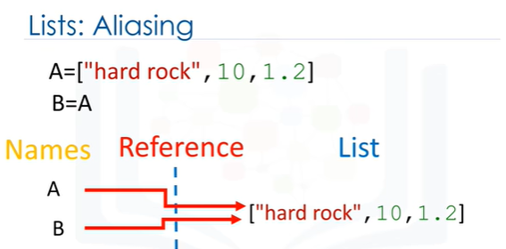

Multiple names referring to the same object is known as aliasing.

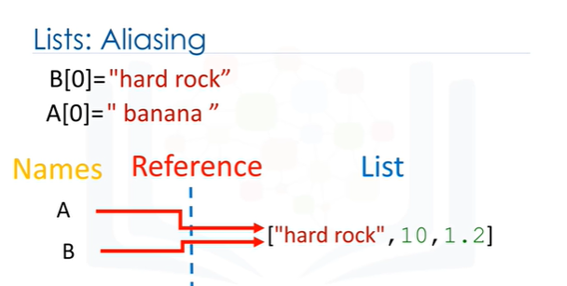

We know from the last slide that the first element in B is set as hard rock.

If we change the first element in “A” to “banana” we get a side effect; the value of B will change as a consequence.

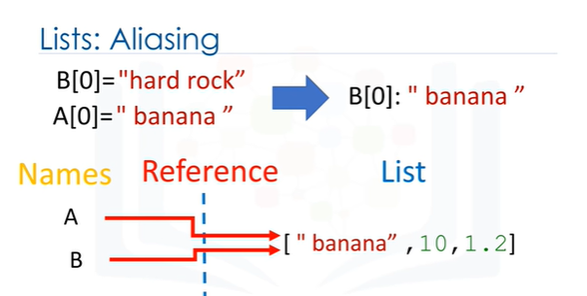

"A" and “B” are referencing the same list, therefore if we change "A“, list "B" also changes.

If we check the first element of B after changing list ”A” we get banana instead of hard rock.

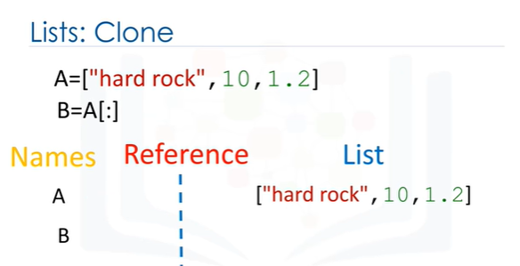

You can clone list “A” by using the following syntax.

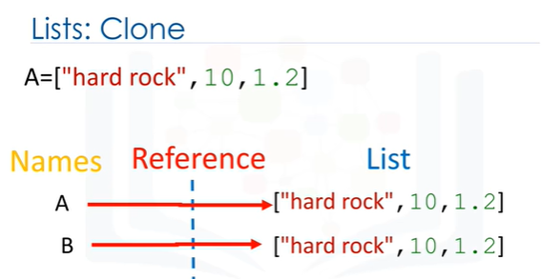

Variable "A" references one list.

Variable “B” references a new copy or clone of the original list.

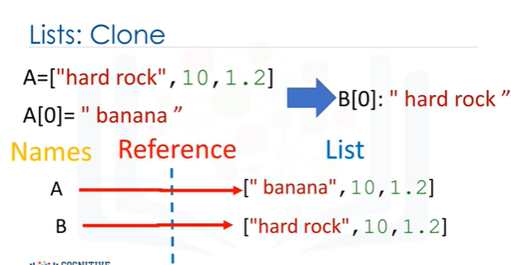

Now if you change “A”, "B" will not change.

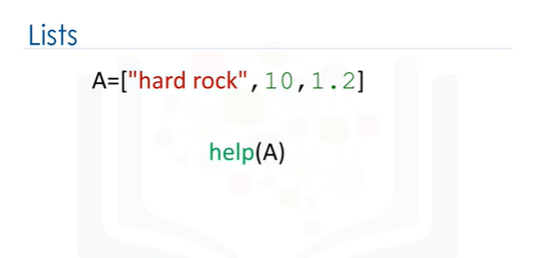

We can get more info on lists, tuples and many other objects in Python using the help command.

Simply pass in the list, tuple or any other Python object.

See the labs for more things you can do with lists.

# Sets

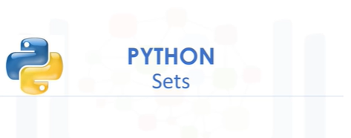

Let’s cover sets; they are also a type of collection.

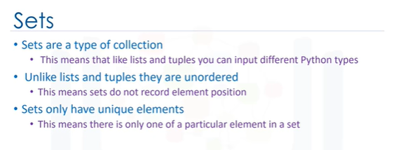

Sets are a type of collection. This means that like lists and tuples, you

can input different python types. Unlike lists and tuples they are unordered.

This means sets do not record element position. Sets only have unique elements.

This means there is only one of a particular element in a set.

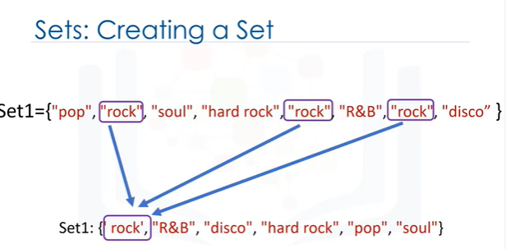

To define a set, you use curly brackets You place the elements of a set within the

curly brackets. You notice there are duplicate items.

When the actual set is created, duplicate items will not be present.

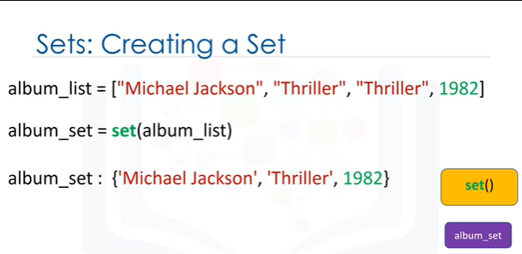

You can convert a list to a set by using the function set; this is called type-casting.

You simply use the list as the input to the function set.

The result will be a list converted to a set. Let's go over an example

We start off with a list. We input the list to the function set.

The function set returns a set. Notice how there are no duplicate elements.

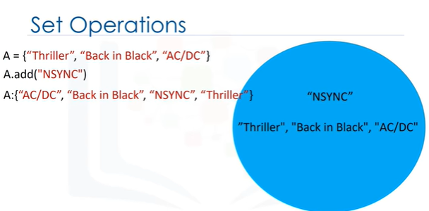

Let’s go over Set Operations; these can be used to change the set.

Consider the set “A”. Let's represent this set with a circle.

If you are familiar with sets this can be part of a Venn diagram.

A Venn diagram is a tool that uses shapes usually to represent sets.

We can add an item to a set using the add method.

We just put the set name followed by a dot, then the add method.

The argument is the new element of the set we would like to add, in this case, "NSYNC".

The set "A" now has "NSYNC” as an item.

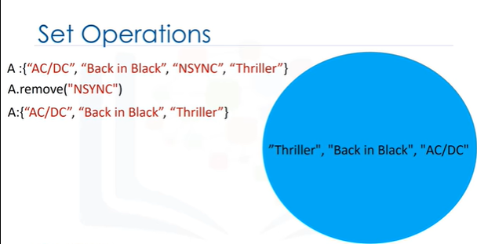

If we add the same item twice, nothing will

happen as there can be no duplicates in a set.

Let’s say we would like to remove NSYNC from set A.

We can also remove an item from a set using the remove method.

We just put the set name followed by a dot then the remove method.

The argument is the element of the set we would like to remove, in this case, "NSYNC".

After the remove method is applied to the set, set "A" dose does not contain the item "NSYNC”.

You can use this method for any item in the set.

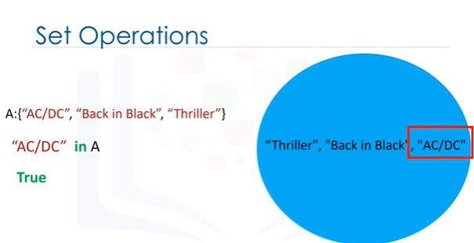

We can verify if an element is in the set using the "in" command as follows.

The command checks if the item, in this case, "AC/DC" is in the set. If the item is in the set, it returns true.

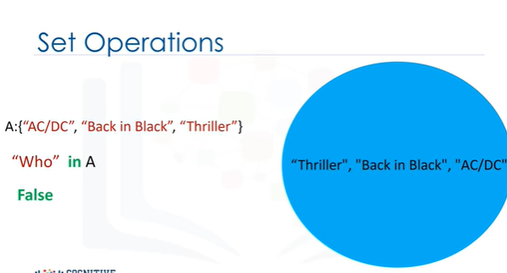

If we look for an item that is not in the set, in this case for the item “Who”, as the item is not in the set, we will get a false.

These are types of mathematical set operations; there are other operations we can do.

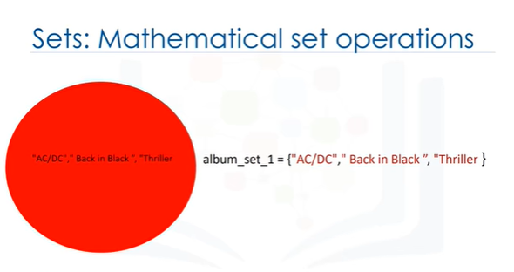

There are lots of useful mathematical operations we can do between sets.

Let's define the set "album set 1,“ we can represent it using a red circle or Venn diagram.

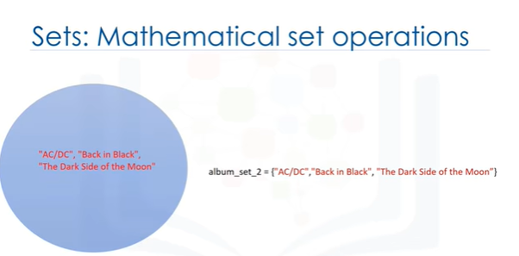

Similarly, we can define the set "album set 2”.

We can also represent it using a blue circle or Venn diagram.

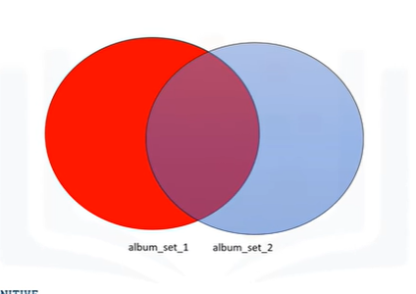

The Intersection of two sets is a new set containing elements which are in both of those

sets. It's helpful to use Venn diagrams.

The two circles that represent the sets combine; the overlap represents the new set.

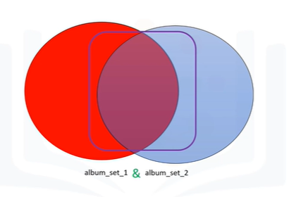

As the overlap is comprised of the red circle and blue circle, we define the intersection

in terms of “and.” In Python, we use the ampersand to find the

union of two sets. If we overlay the values of the set over the circle placing the common elements in the overlapping area, we see the correspondence.

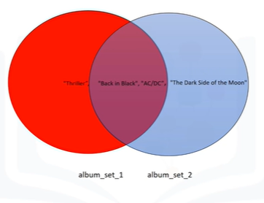

After applying the Intersection operation, all the items that are not in both sets disappear.

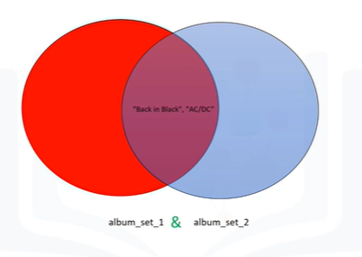

In Python, we simply just place the ampersand between the two sets.

We see that both "AC/DC" and "Back in Black" are in both sets.

The result is a new set album, set 3, containing all the elements in both album set 1 and album set 2.

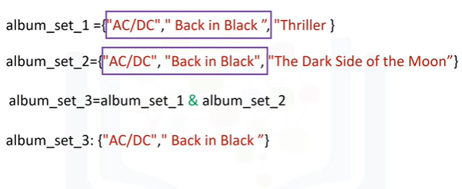

The union of two sets is the new set of elements which contain all the items in both sets. We can find the union of the sets album set 1 and album set 2 as follows.

The result is a new set that has all the elements of album set 1 and album set 2.

This new set is represented in green.

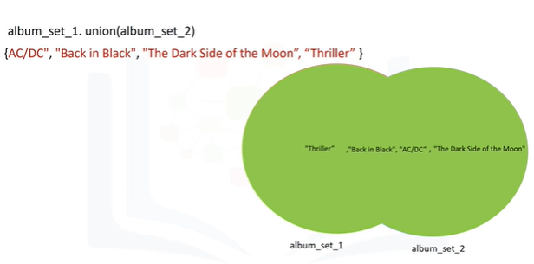

Consider the new album set album set 3; the set contains the elements "AC/DC" and "Back in Black”.

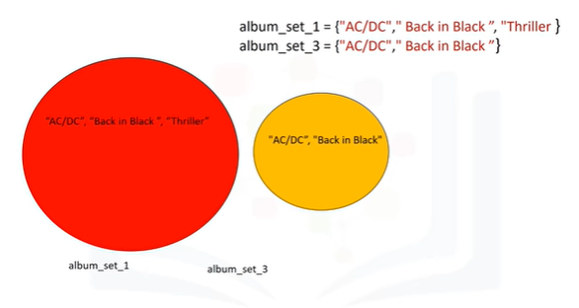

We can represent this with a Venn diagram, as all the elements in album set 3 are in album set 1.

The circle representing album set 1 encapsulates the circle representing album set 3.

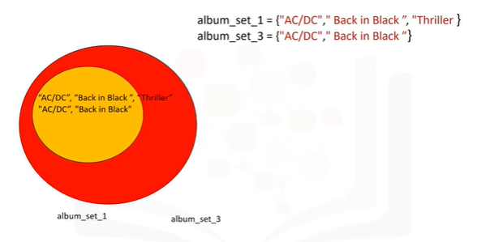

We can check if a set is a subset using the is subset method.

As album set 3 is a subset of the album set 1, the result is true.

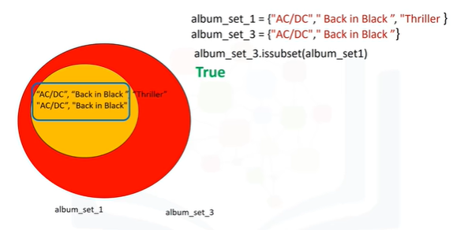

There is a lot more you can do with sets. Check out the lab for more examples.

# Dictionaries

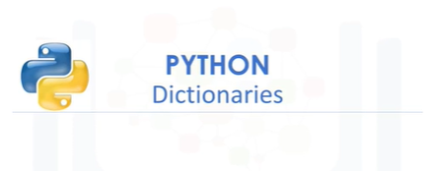

Let’s cover dictionaries in Python. Dictionaries are a type of collection in Python.

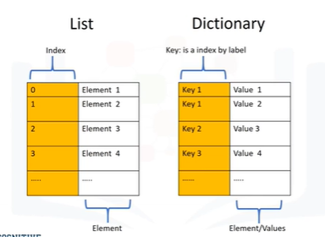

If you recall, a list has integer indexes.

These are like addresses.

A list also has elements.

A dictionary has keys and values.

The key is analogous to the index, they are like addresses but they don’t have to be integers.

They are usually characters, the values are similar to the elements in a list and contain information.

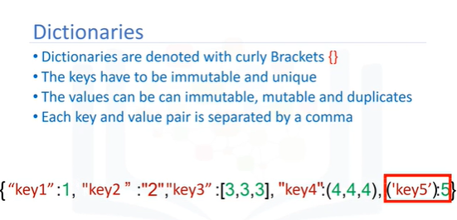

To create a dictionary, we use curly brackets.

The keys are the first elements, they must be immutable and unique.

Each key is followed by a value separated by a colon.

The values can be immutable, mutable and duplicates.

Each key and value pair is separated by a comma.

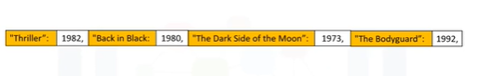

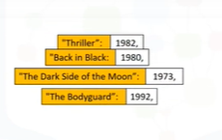

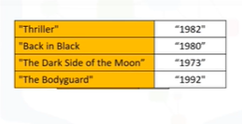

Consider the following example of a dictionary, the album title is the key and the value is the release data.

We can use yellow to highlight the keys and leave the values in white.

It is helpful to use the table to visualize a dictionary, where the first column represents the keys and the second column represents the values.

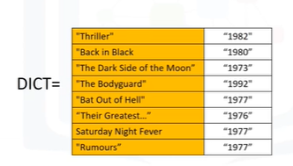

We can add a few more examples to the dictionary.

We can also assign the dictionary to a variable.

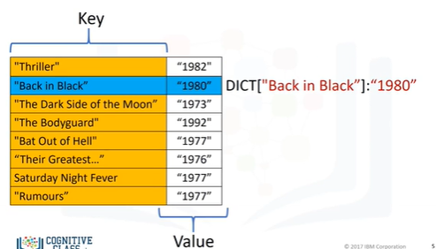

The key is used to look up the value.

We use square brackets, the argument is the key.

This outputs the value.

Using the key of "Back in Black," this returns the value of 1980.

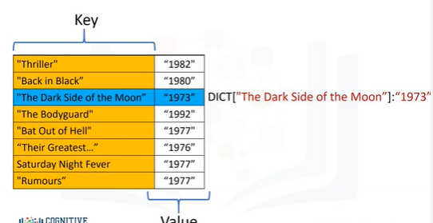

The key "The Dark Side of the Moon," gives us the value of 1973.

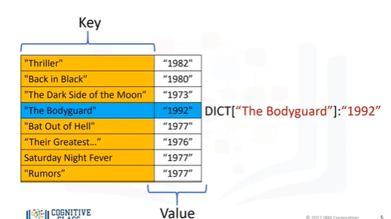

Using the Key "The Bodyguard," gives us the value 1992, and so on.

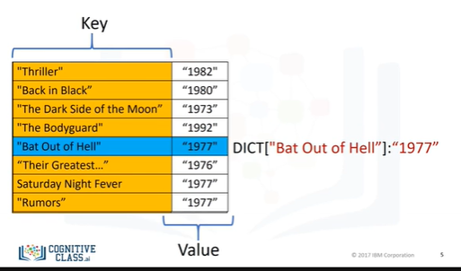

We can add a new entry to the dictionary as follows.

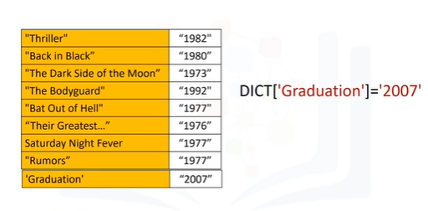

This will add the value 2007 with the new key called "Graduation."

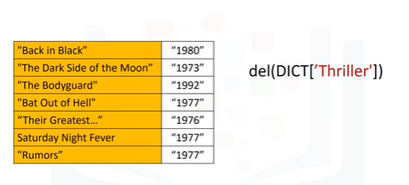

We can delete an entry as follows.

This gets rid of the key "Thriller" and its value.

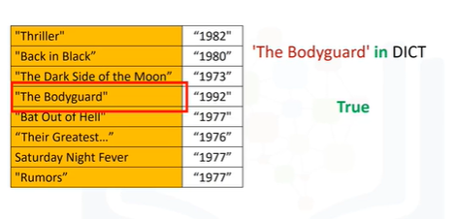

We can verify if an element is in the dictionary using the in command as follows.

The command checks the keys.

If they are in the dictionary, they return a true.

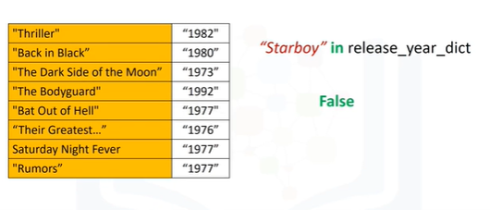

If we try the same command with a key that is not in the dictionary, we get a false.

If we try with another key that is not in the dictionary, we get a false.

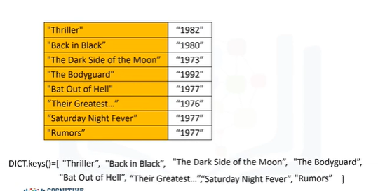

In order to see all the keys in a dictionary, we can use the method keys to get the keys.

The output is a list like object with all the keys.

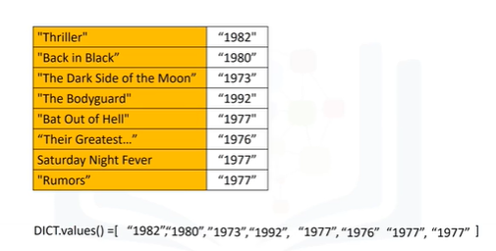

In the same way, we can obtain the values using the method values.

Check out the labs for more examples and info on dictionaries.

# Module 3 - Python Programming Fundamentals

Conditions and Branching

Loops

Functions

Objects and Classes

# Conditions and Branching

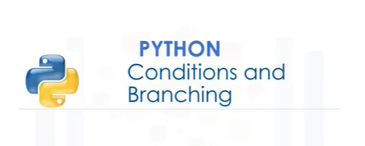

In this video you will learn about Conditions and Branching.

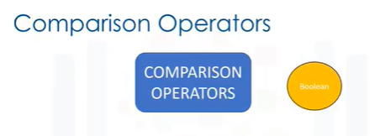

Comparison operations compare some value or operand, then, based on some condition they produce a Boolean.

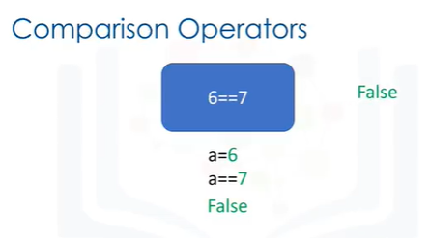

Let's say we assign "a" value of “a” to 6. We can use the equality operator denoted with two equal signs to determine if two values are equal, in this case, if seven is equal to 6.

In this case, as six is not equal to 7, the result is false.

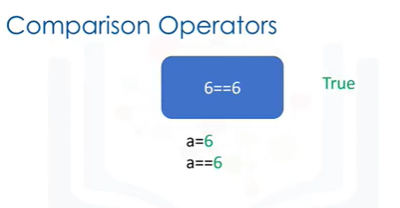

If we performed an equality test for the value 6, the two values would be equal.

As a result, we would get a true.

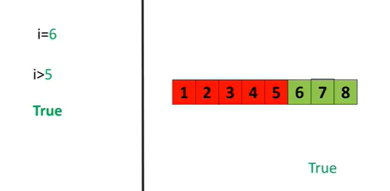

Consider the following equality comparison operator.

If the value of the left operand, in this case, the variable “i” is greater than the value of the right operand, in this case, 5, the condition becomes true, or else we get a false.

Let's display some values for "i" on the left.

Let’s see the values greater than 5 in green and the rest in red.

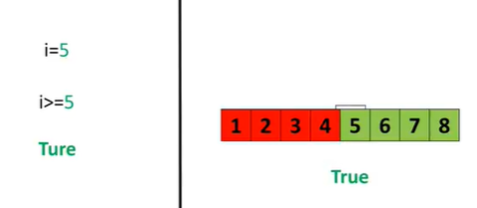

If we set "i" equal to 6, we see that 6 is larger than 5, and as a result, we get a true.

We can also apply the same operations to floats.

If we modify the operator as follows, if the left operand “i” is greater than or equal to the value of the right operand, in this case, 5, then the condition becomes true.

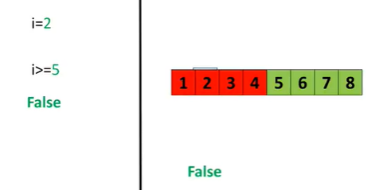

In this case, we include the value of 5 in the number line and the color changes to green accordingly.

If we set the value of "i" equal to 5, the operand will produce a true.

If we set the value of “i” to 2, we would get a false because 2 is less than 5.

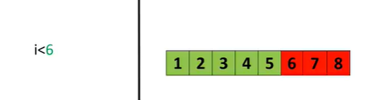

We can change the inequality, if the value of the left operand, in this case, “i”

is less than the value of right operand, in this case, 6, then condition becomes true.

Again, we can represent this with a colored number line.

The areas where the inequality is true are marked in green and red where the inequality is false.

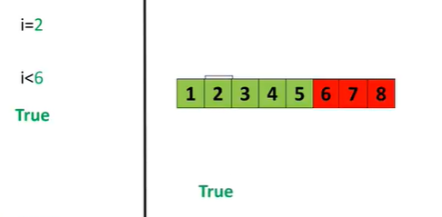

If the value for "i" is set to 2, the result is a true, as 2 is less than 6.

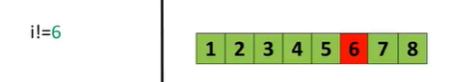

The inequality test uses an explanation mark preceding the equal sign, if two operands are not equal, then the condition becomes true.

We can use a number line.

When the condition is true the corresponding numbers are marked in green and red for where the condition is false.

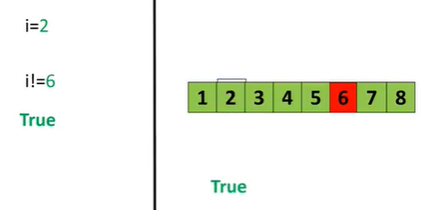

If we set “I” equal to 2, the operator is true as 2 is not equal to 6.

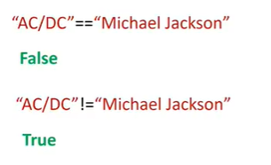

We compare strings as well.

Comparing “AC/DC” and “Michael Jackson” using the equality test, we get a false, as the strings are not the same.

Using the inequality test, we get a true, as the strings are different.

See the labs for more examples.

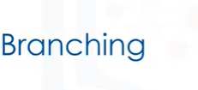

Branching allows us to run different statements for a different input.

It's helpful to think of an “if statement” as a locked room:

If the statement is true, you can enter the room, and your program can run some predefined task.

If the statement is false, your program will skip the task.

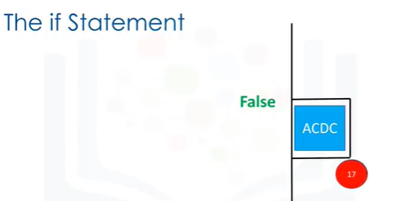

For example, consider the blue rectangle representing an ACDC concert.

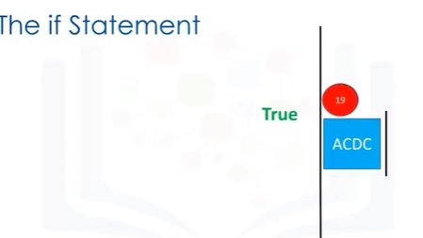

If the individual is 18 or older, they can enter the ACDC concert.

If they are under the age of 18, they cannot enter the concert.

Individual proceeds to the concert, their age is 17, therefore they are not granted access to the concert, and they must move on.

If the individual is 19, the condition is true, they can enter the concert; then they can move on.

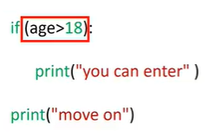

This is the syntax of the if statement from our previous example.

We have the if statement We have the expression that can be true or false, the brackets are not necessary.

We have a colon.

Within an indent, we have the expression that is run if the condition is true.

The statements after the if statement will run regardless if the condition is true or false.

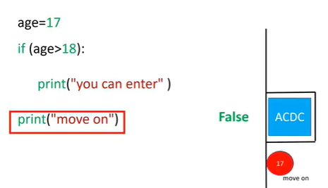

For the case where the age is 17, we set the value of the variable age to 17.

We check the if statement; the statement is false, therefore the program will not execute the statement to print "you will enter."

In this case, it will just print “move on.”

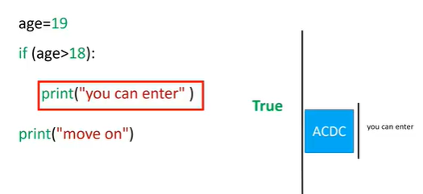

For the case where the age is 19, we set the value of the variable age to 19.

We check the if statement.

The statement is true, therefore, the program will execute the statement to print “you will enter.”

Then it will just print “move on.”

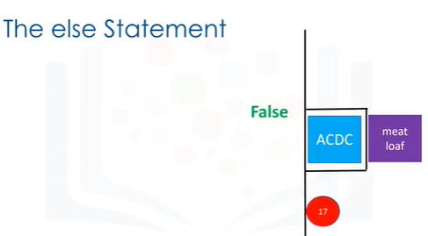

The “else statement” will run a different block of code, if the same condition is false.

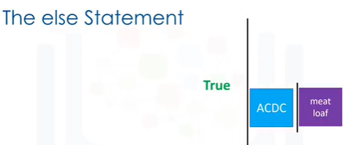

Let’s use the ACDC concert analogy again; if the user is 17, they cannot go to the ACDC concert, but they can go to the Meat Loaf concert represented by the purple square.

If the individual is 19, the condition is true.

They can enter the ACDC concert, then they can move on as before.

The syntax of the else statement is similar.

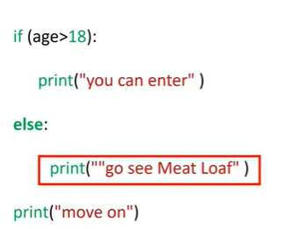

We simply append the statement else.

We then add the expression we would like to execute with an indent.

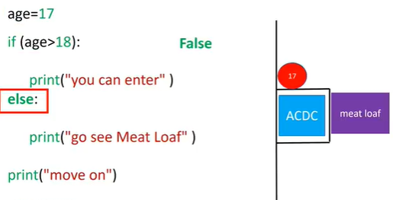

For the case where the age is 17, we set the value of the variable age to 17.

We check the if statement.

The statement is false, therefore, we progress to the else statement.

We run the statement in the indent.

This corresponds to the individual attending the Meat Loaf concert.

The program will then continue running.

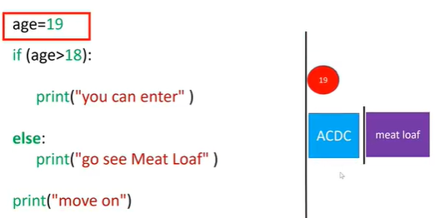

For the case where the age is 19, we set the value of the variable age to 19.

We check the if statement.

The statement is true, therefore, the program will execute the statement to print “you will enter.”

The program skips the expressions in the else statement and continues to run the rest of the expressions.

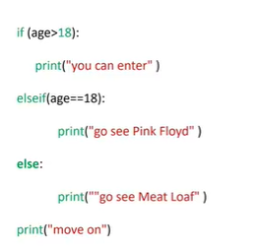

The elif statement, short for “else if,” allows us to check additional conditions, if the proceeding condition is false.

If the condition is true, the alternate expressions will be run.

Consider the concert example, if the individual is 18, they will go to the Pink Floyd concert, instead of attending the ACDC or Meat Loaf concert.

The person of 18 years of age enters the area as they are not over 19 years of age.

They cannot see ACDC, but as they are 18 years, they attend Pink Floyd.

After seeing Pink Floyd, they move on.

The syntax of the “elseif statement” is similar.

We simply add the statement elseif with the condition.

We then add the expression we would like to execute if the statement is true, with an indent.

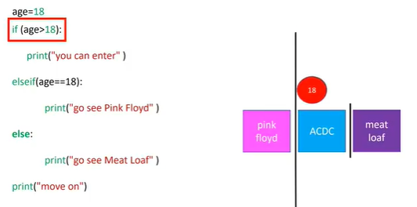

Let's illustrate the code on the left.

An 18-year-old enters.

They are not older than 18 years of age, therefore the condition is false, so the condition of the else if statement is checked.

The condition is true, so then we would print “go see Pink Floyd.“

Then we would move on, as before.

If the variable age was 17, the statement “go see Meat Loaf” would print.

Similarly, if the age was greater than 18, the statement “you can enter” would print.

Check the labs for more examples.



Now let’s take a look at logic operators.

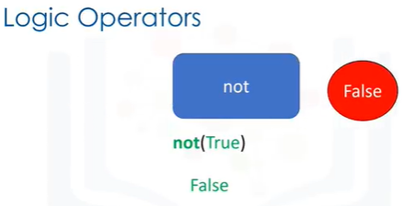

Logic operations take Boolean values and produce different Boolean values.

The first operation is the not operator.

If the input is true, the result is a false.

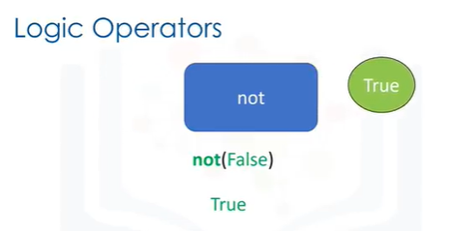

Similarly, if the input is false, the result is a true.

Let A and B represent Boolean variables.

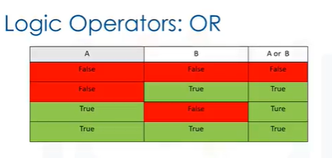

The “or” operator takes in the two values, and produces a new Boolean value.

We can use this table to represent the different values.

The first column represents the possible values of A.

The second column represents the possible values of B.

The final column represents the result of applying the “or operation.”

We see the “or operator” only produces a false if all the Boolean values are false.

The following lines of code will print out: “This album was made in the 70's or 90's”

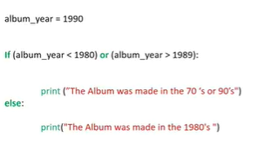

if the variable album year does not fall in the 80s.

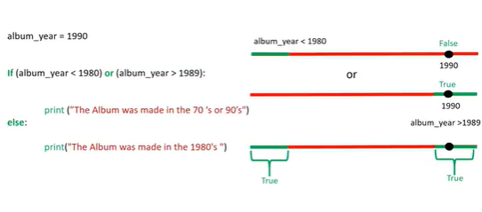

Let's see what happens when we set the album year to 1990.

The colored number line is green when the condition is true and red when the condition is false.

In this case, the condition is true.

Examining the second condition, we see that 1990 is greater than 1989, so the condition is also true.

We can verify by examining the corresponding second number line.

In the final number line, the green region indicates where the area is true.

This region corresponds to where at least one statement is true.

We see that 1990 falls in the area.

Therefore we execute the statement.

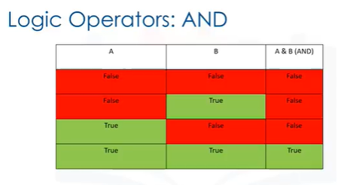

Let A and B represent Boolean variables the “and operator” takes in the two values, and produces a new Boolean value.

We can use this table to represent the different values.

The first column represents the possible values of A.

The second column represents the possible values of B.

The final column represents the result of applying the “and operation.”

We see the “or operator” only produces a true if all the Boolean values are true.

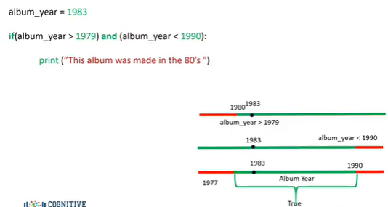

The following lines of code will print out: “This album was made in the 80’s” if the variable album year is between 1980 and 1989.

Let's see what happens when we set the album year to 1983.

As before, we can use the colored number line to examine where the condition is true.

In this case, 1983 is larger than 1980, so the condition is true.

Examining the second condition, we see that 1990 is greater than 1983 so this condition is also true.

We can verify by examining the corresponding second number line.

In the final number line, the green region indicates where the area is true.

Similarly, this region corresponds to where both statements are true.

We see that 1983 falls in the area.

Therefore we execute the statement.

Branching allows us to run different statements for different inputs.

# Loops

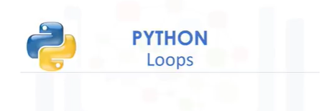

In this video we will cover Loops, in particular “for loops” and “while loops.”

We will use many visual examples in this video. See the labs for examples with data.

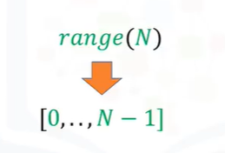

Before we talk about loops, let’s go over the range function.

The range function outputs an ordered sequence as a list “i”.

If the input is a positive integer, the output is a sequence, the sequence contains the same

number of elements as the input, but starts at zero.

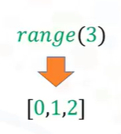

For example, if the input is 3 the output is the sequence 0,1,2.

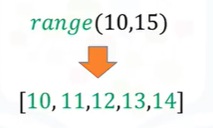

If the range function has two inputs where the first input is larger than the second input, the output is a sequence that starts at the first input.

Then the sequence iterates up to, but not including the second number.

For the input 10 and 15, we get the following sequence.

See the labs for more capabilities of the range function.

Please note: if you use Python 3 the range function will not generate a list explicitly like in Python 2.

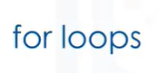

In this section, we will cover “for loops”.

We will focus on lists, but many of the procedures can be used on tuples. Loops perform a task over and over.

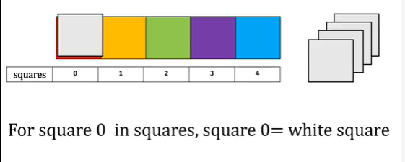

Consider the group of colored squares.

Let's say we would like to replace each colored square with a white square.

Let's give each square a number to make things a little easier and refer to all the group of squares as squares.

If we wanted to tell someone to replace square 0 with a white square, we would say, “=Replace square 0 with a white square” or we can say, “For square 0 in squares, square 0= white square.”

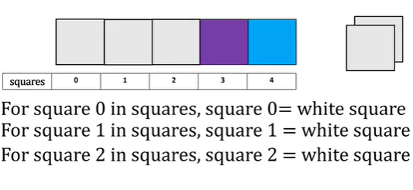

Similarly, for the next square, we can say, “For square 1 in squares, square 1 = white square.”

For the next square, we can say, “For square 2 in squares, square 2= white square.”

We repeat the process for each square. The only thing that changes is the index of the square we are referring to.

If we are going to perform a similar task in Python, we cannot use actual squares.

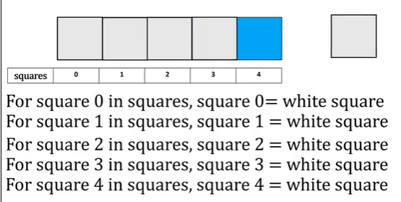

So let's use a list to represent the boxes.

Each element in the list is a string representing the color.

We want to change the name of the color in each element to white.

Each element in the list has the following index.

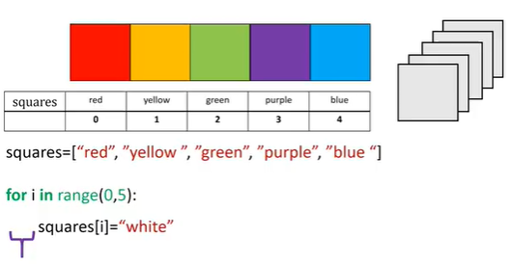

This is the syntax to perform a loop in Python.

Notice the indent.

The range function generates a list.

The code will simply repeat everything in the indent 5 times.

If you were to change the value to 6, it would do it 6 times, however, the value of “i” is incremented by one each time.

In this segment we change the i-th element of the list to the string white.

The value of “i” is set to zero.

Each iteration of the loop starts at the beginning of the indent.

We then run everything in the indent.

The first element in the list is set to white.

We then go to the start of the indent.

We progress down each line. When we reach the line to change the value of the list, we set the value of index 1 to white.

The value of “i” increases by one. We repeat the process for index 2.

The process continues for the next index until we have reached the final element.

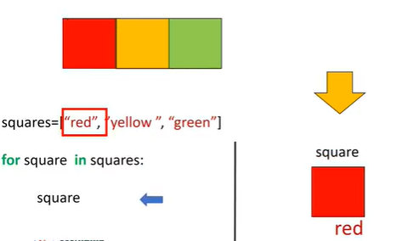

We can also iterate through a list or tuple directly in Python, we do not even need to use indexes.

Here is the list squares.

Each iteration of the list we pass one element of the list squares to the variable square.

Let's display the value of the variable square on this section.

For the first iteration, the value of square is red.

We then start the second iteration.

For the second iteration, the value of square is yellow.

We then start the third iteration.

For the final iteration, the value of square is green.

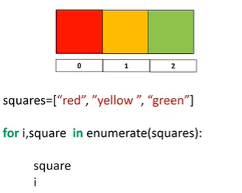

A useful function for iterating data is enumerate.

It can be used to obtain the index and the element in the list.

Let's use the box analogy, with the numbers representing the index of each square.

This is the syntax to iterate through a list to provide the index of each element.

We use the list squares and use the names of the colors to represent the colored squares.

The argument of the function enumerate is the list, in this case, squares.

The variable "i" is the index, and the variable square is the corresponding element in the list.

Let's use the left part of the screen to display the different values of the variable square, and "i" for the various iterations of the loop.

For the first iteration, the value of the variable is red, corresponding to the zeroth index, and the value for “i” is zero.

For the second iteration, the value of the variable square is yellow and the value of "i" corresponds to its index, i.e., 1.

We repeat the process for the last index.



“While loops” are similar to “for loops”, but instead of executing a statement a set number of times, a while loop will only run if a condition is met.

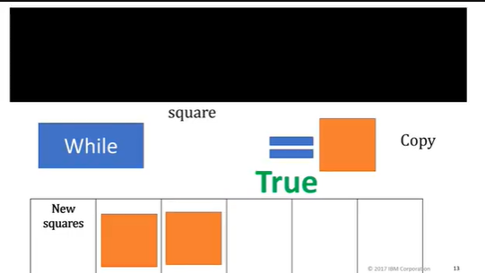

Let’s say we would like to copy all the orange squares from the list squares to the list new squares, but we would like to stop if we encounter a non-orange square.

We don't know the value of the squares beforehand. We would simply continue the process while the square is orange, or see if the square equals orange, if not, we would stop.

For the first example, we would check if the square was orange.

It satisfies the condition, so we would copy the square.

We repeat the process for the second square.

The condition is met, so we copy the square.

In the next iteration, we encounter a purple square.

The condition is not met so we stop the process.

This is essentially what a “while loop” does.

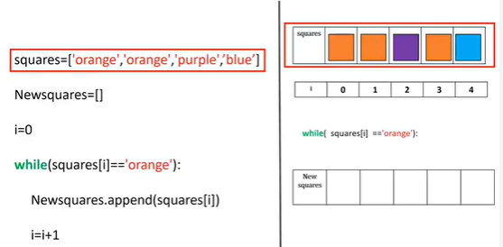

Let's use the figure on the left to represent the code.

We will use a list with the names of the color to represent the different squares.

We create an empty list of “New Squares.”

In reality, the list is of indeterminate size.

We start the index at zero.

The “while” statement will repeatedly execute the statements within the indent until the condition inside the bracket is false.

We append the value of the first element of the list squares to the list "New Squares."

We increase the value of “i” by one.

We append the value of the second element of the list squares to the list "New Squares.“

We increment the value of “i”.

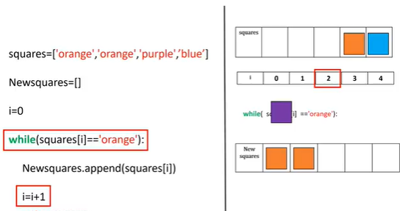

Now the value in the array “Squares” is purple.

Therefore, the condition for the “while” statement is false and we exit the loop.

Check out the labs for more examples of loop, many with real data.

# Functions

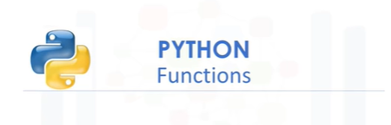

In this video we will cover functions.

You will learn how to use some of Python’s built-in functions as well as how to build your own functions.

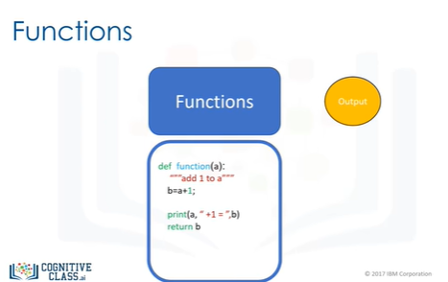

Functions take some input then produce some output or change.

The function is just a piece of code you can reuse.

You can implement your own function, but in many cases, you use other people’s functions.

In this case, you just have to know how the function works and in some cases how to import the functions.

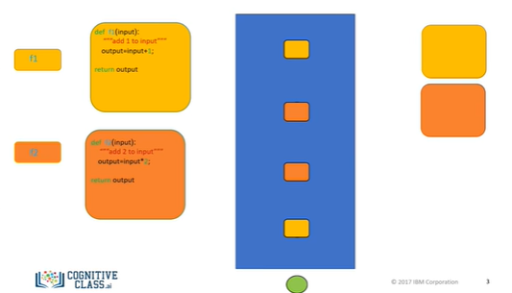

Let the orange and yellow squares represent similar blocks of code.

We can run the code using some input and get an output.

If we define a function to do the task we just have to call the function.

Let the small squares represent the lines of code used to call the function.

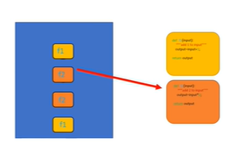

We can replace these long lines of code by just calling the function a few times.

Now we can just call the function, our code is much shorter. The code performs the same task.

You can think of the process like this: when we call the function f1, we pass an input to the function.

These values are passed to all those lines of code you wrote.

This returns a value, you can use the value.

For example, you can input this value to a new function f2.

When we call this new function f2, the value is passed to another set of lines of code.

The function returns a value.

The process is repeated passing the values to the function you call.

You can save these functions and reuse them, or use other people’s functions.

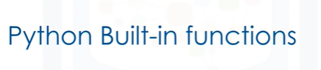

Python has many built-in functions, you don't have to know how those functions work internally, but simply what task those functions perform.

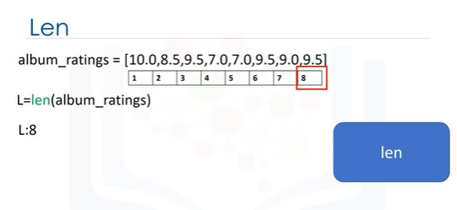

The function len takes in an input of type sequence, such as a string or list, or type collection, such as a dictionary or set, and returns the length of that sequence or collection.

Consider the following list.

The len function takes this list as an argument, and we assign the result to the variable L.

The function determines there are 8 items in the list, then returns the length of the list, in this case, 8.

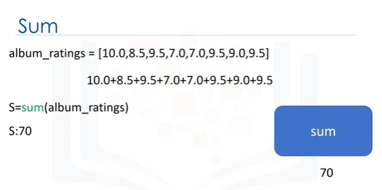

The function sum takes in an iterable like a tuple or list and returns the total of all the elements.

Consider the following list.

We pass the list into the sum function and assign the result to the variable S.

The function determines the total of all the elements, then returns it, in this case, the value is 70.

There are two ways to sort a list.

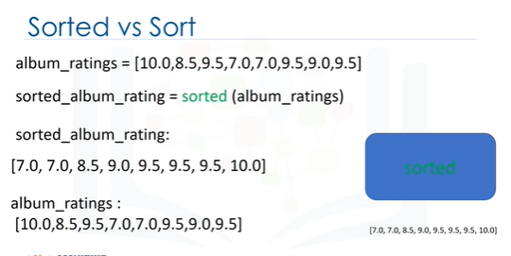

The first is using the function sorted.

We can also use the list method sort.

Methods are similar to functions.

Let's use this as an example to illustrate the difference.

The function sorted Returns a new sorted list or tuple.

Consider the list album ratings.

We can apply the function sorted to the list

album ratings and get a new list sorted album rating.

The result is a new sorted list.

If we look at the list album ratings, nothing has changed. Generally, functions take an input, in this case, a list.

They produce a new output, in this instance, a sorted list.

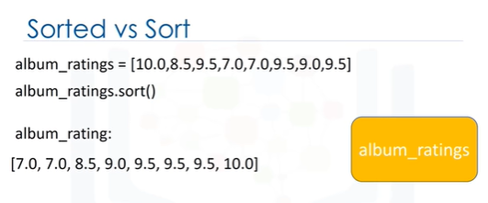

If we use the method sort, the list album ratings will change and no new list will be created.

Let's use this diagram to help illustrate the process.

In this case, the rectangle represents the list album ratings.

When we apply the method sort to the list, the list album rating changes.

Unlike the previous case, we see that the list album rating has changed.

In this case, no new list is created.



Now that we have gone over how to use functions in Python, let’s see how to build our own functions.

We will now get you started on building your own functions in python.

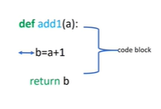

This is an example of a function in python that returns its input value + 1.

To define a function, we start with the keyword def.

The name of the function should be descriptive of what it does.

We have the function formal parameter "A" in parentheses.

Followed by a colon.

We have a code block with an indent, for this case, we add 1 to "A" and assign it to B.

We return or output the value for b.

After we define the function, we can call it.

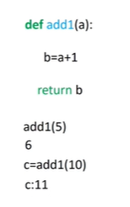

The function will add 1 to 5 and return a 6.

We can call the function again, this time assign it to the variable "c" The value for 'c' is 11.

Let's explore this further.

Let's go over an example when you call a function.

It should be noted that this is a simplified model of Python, and Python does not work like this under the hood.

We call the function giving it an input, 5.

It helps to think of the value of 5 as being passed to the function.

Now the sequences of commands are run, the value of "A" is 5.

"B" would be assigned a value of 6.

We then return the value of b, in this case, as b was assigned a value of 6, the function returns a 6.

If we call the function again, the process starts from scratch, we pass in an 8.

The subsequent operations are performed.

Everything that happened in the last call will happen again with a different value of "A"

The function returns a value, in this case, 9.

Again, this is just a helpful analogy.

Let’s try and make this function more complex.

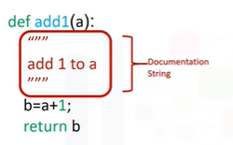

It's customary to document the function on the first few lines, this tells anyone who uses the function what it does.

This documentation is surrounded in triple quotes.

You can use the help command on the function to display the documentation as follows.

This will printout the function name and the documentation.

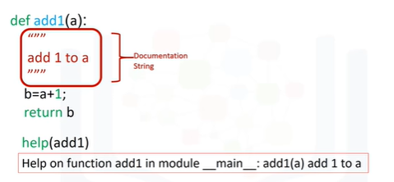

We will not include the documentation in the rest of the examples.

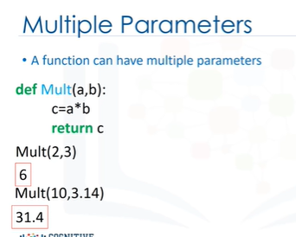

A function can have multiple parameters.

The function mult multiplies two numbers, in other words, it finds their product.

If we pass the integers 2 and 3, the result is a new integer.

If we pass the integer 10 and the float 3.14, the result is a float 31.4.

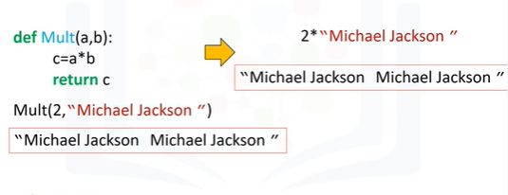

If we pass in the integer two and the string “Michael Jackson,” the string Michael Jackson is repeated two times.

This is because the multiplication symbol can also mean repeat a sequence.

If you accidentally multiply an integer and a String instead of two integers, you won’t get an error.

Instead, you will get a String, and your program will progress, potentially failing later because you have a String where you expected an integer.

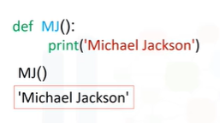

This property will make coding simpler, but you must test your code more thoroughly.

In many cases a function does not have a return statement.

In these cases, Python will return the special “None” object.

Practically speaking, if your function has no return statement, you can treat it as if the function returns nothing at all.

The function MJ simply prints the name 'Michael Jackson’.

We call the function.

The function prints “Michael Jackson.”

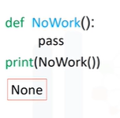

Let's define the function “No work” that performs no task.

Python doesn’t allow a function to have an empty body, so we can use the keyword pass, which doesn’t do anything, but satisfies the requirement of a non-empty body.

If we call the function and print it out, the function returns a None.

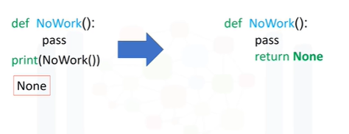

In the background, if the return statement is not called, Python will automatically return a None.

It is helpful to view the function No Work with the following return statement.

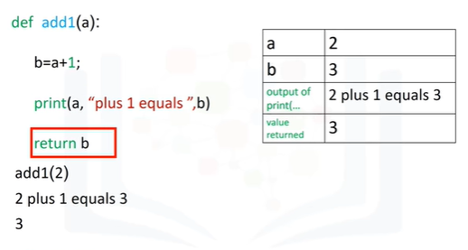

Usually, functions perform more than one task.

This function prints a statement then returns a value.

Let's use this table to represent the different values as the function is called.

We call the function with an input of 2.

We find the value of b.

The function prints the statement with the values of a and b.

Finally, the function returns the value of b, in this case, 3.

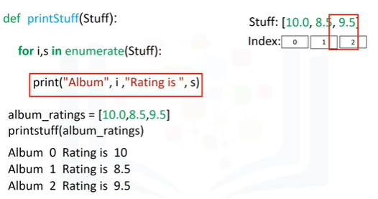

We can use loops in functions.

This function prints out the values and indexes of a loop or tuple.

We call the function with the list album ratings as an input.

Let's display the list on the right with its corresponding index.

Stuff is used as an input to the function enumerate.

This operation will pass the index to i and the value in the list to “s”.

The function would begin to iterate through the loop.

The function will print the first index and the first value in the list.

We continue iterating through the loop.

The values of i and s are updated.

The print statement is reached.

Similarly, the next values of the list and index are printed.

The process is repeated. The values of i and s are updated.

We continue iterating until the final values in the list are printed out.

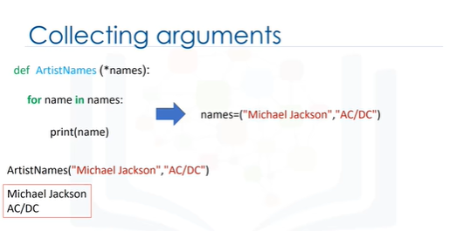

Variadic parameters allow us to input a variable number of elements.

Consider the following function, the function has an asterisk on the parameter names.

When we call the function, three parameters are packed into the tuple names.

We then iterate through the loop, the values are printed out accordingly.

If we call the same function with only two parameters as inputs, the variable names only contain two elements.

The result is only two values are printed out.

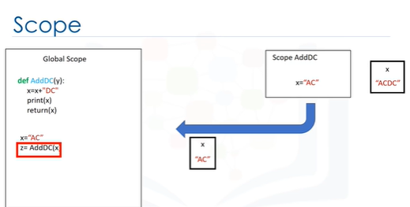

The scope of a variable is the part of the program where that variable is accessible.

Variables that are defined outside of any function are said to be within the global scope, meaning they can be accessed anywhere after they are defined.

Here we have a function that adds the string DC to the parameter x.

When we reach the part where the value of x is set to AC, this is within the global scope, meaning x is accessible anywhere after it is defined.

A variable defined in the global scope is called a global variable.

When we call the function, we enter a new scope or the scope of AddDC.

We pass as an argument to the AddDC function, in this case, AC.

Within the scope of the function, the value of x is set to ACDC.

The function returns the value and is assigned to z.

Within the global scope, the value z is set to ACDC After the value is returned, the scope of the function is deleted.

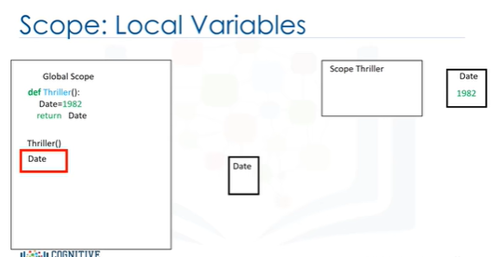

Local variables only exist within the scope of a function.

Consider the function thriller, the local variable Date is set to 1982.

When we call the function, we create a new scope.

Within that scope of the function, the value of the date is set to 1982.

The value of date does not exist within the global scope.

Variables inside the global scope can have the same name as variables in the local scope with no conflict.

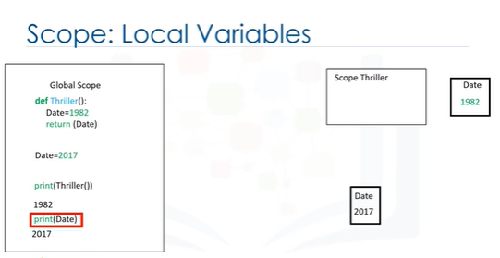

Consider the function thriller, the local variable Date is set to 1982.

The global variable date is set to 2017.

When we call the function, we create a new scope.

Within that scope, the value of the date is set to 1982.

If we call the function, it returns the value of Date in the local scope, in this case, 1982.

(click6) When we print in the global scope, we use the global variable value.

The global value of the variable is 2017.

Therefore, the value is set to 2017.

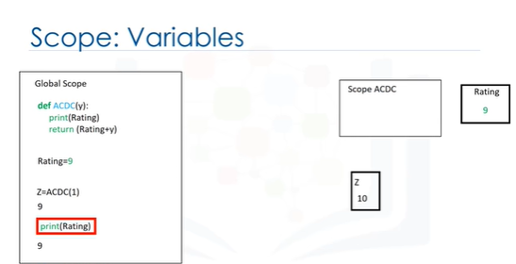

If a variable is not defined within a function, Python will check the global scope.

Consider the function "AC-DC“.

The function has the variable rating, with no value assigned.

If we define the variable rating in the global scope, then call the function, Python will see there is no value for the variable Rating.

As a result, python will leave the scope and check if the variable Ratings exists in the global scope.

It will use this value of Ratings in the global scope within the scope of "AC-DC“.

In the function, will print out a 9.

The value of z in the global scope will be 10, as we added one.

The value of rating will be unchanged within the global scope.

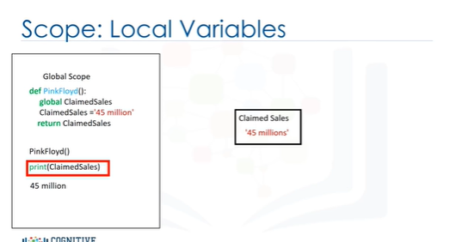

Consider the function Pink Floyd.

If we define the variable Claimed Sales with the keyword global, the variable will be a global variable.

We call the function Pink Floyd.

The variable claimed sales is set to the string “45 million” in the global scope.

When we print the variable, we get a value of “45 million.”

There is a lot more you can do with functions.

Check out the lab for more examples.

# Object and Classes

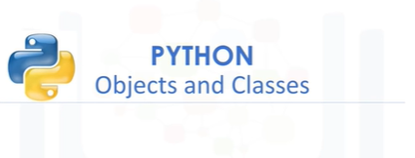

In this module, we are going to talk about objects and classes.

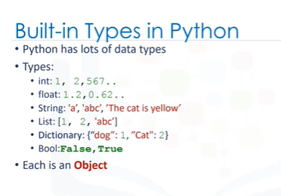

Python has many different kinds of data types: Integers, Floats, Strings, Lists, Dictionaries, Booleans.

In Python each is an object.

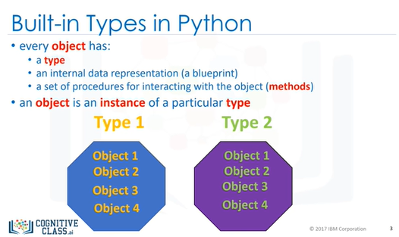

Every object has the following: a type, internal representation, a set of functions called methods to interact with the data.

An object is an instance of a particular type.

For example, we have two types: type one and type two.

We can have several objects of type one as shown in yellow.

Each object is an instance of type one.

We also have several objects of type two shown in green.

Each object is an instance of type two.

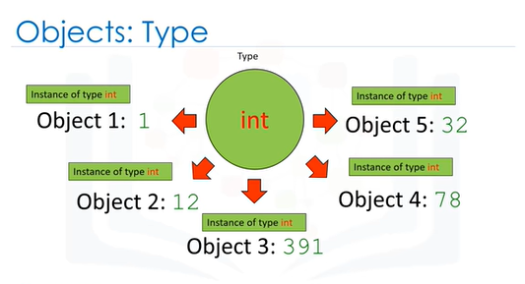

Let’s do several less abstract examples.

Every time we create an Integer, we are creating an instance of type integer, or we are creating an integer object.

In this case, we are creating five instances of type integer or five integer objects.

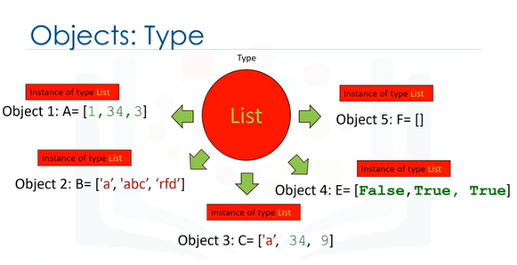

Similarly, every time we create a list, we are creating an instance of type list, or we are creating a list object.

In this case, we are creating five instances of type list or five list objects.

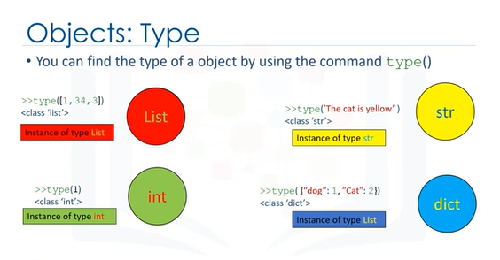

We can find out the type of an object by using the type command.

In this case, we have an object of type list.

We have an object of type integer.

We have an object of type string.

Finally, we have an object of type dictionary.

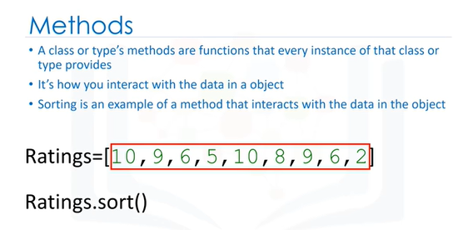

A class or type’s methods are functions that every instance of that class or type provides.

It’s how you interact with the object.

We have been using methods all this time, for example, on lists.

Sorting is an example of a method that interacts with the data in the object.

Consider the list Ratings.

The data is a series of numbers contained within the list.

The method sort will change the data within the object.

We call the method by adding a period at the end of the object’s name and the method’s name we would like to call with parenthesis.

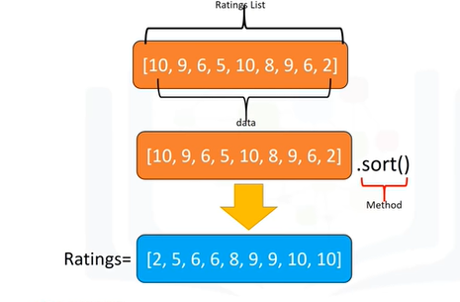

We have the ratings list represented in orange.

The data contained in the list is a sequence of numbers.

We call the sort method.

This changes the data contained in the object.

You can say it changes the state of the object.

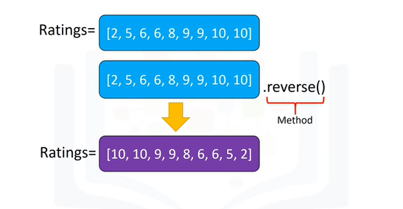

We can call the reverse method on the list, changing the list again.

We call the method, reversing the order of the sequence within the object.

In many cases, you don't have to know the inner workings of the class and its methods.

You just have to know how to use them.

Next we will cover how to construct your own classes.

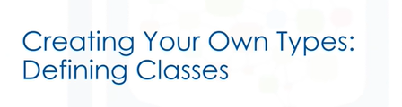

You can create your own type or class in Python.

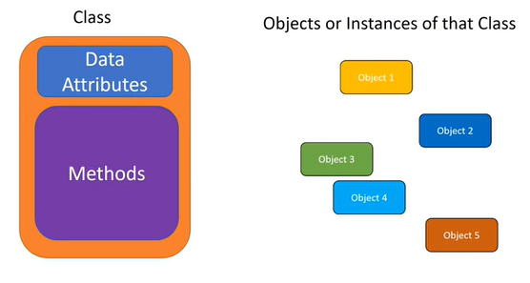

In this section, you will create a class.

The class has data attributes.

The class has methods.

We then create an instances or instances of that class or objects.

The class data attributes define the class.

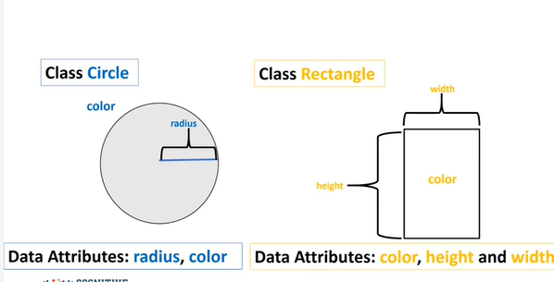

Let's create two classes; the first class will be a circle, the second will be a rectangle.

Let's think about what constitutes a circle.

Examining this image all we need is a radius to define a circle and let's add color to make it easier to distinguish between different instances of the class later.

Therefore, our class data attributes are radius and color.

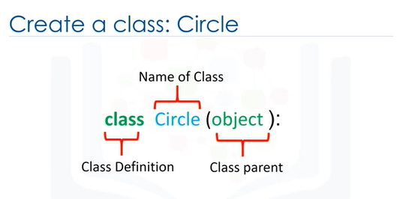

Similarly, examining the image in order to define a rectangle, we need the height and width.

We will also add color to distinguish between instances later.

Therefore, the data attributes are color, height, and width.

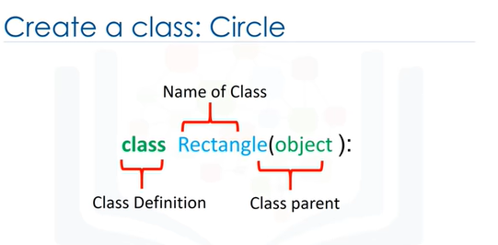

To create the class circle, you will need to include the class definition.

This tells Python you are creating your own class, the name of the class.

For this course in parenthesis, you will always place the term object.

This is the parent of the class.

For the class rectangle, we change the name of the class, but the rest is kept the same.

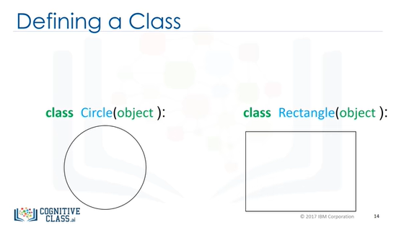

Classes are outlines we have to set the attributes to create objects.

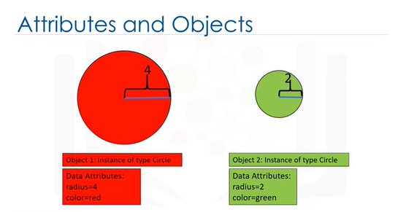

We can create an object that is an instance of type circle.

The color data attribute is red and the data attribute radius is four.

We can also create a second object that is an instance of type circle.

In this case, the color data attribute is green and the data attribute radius is two.

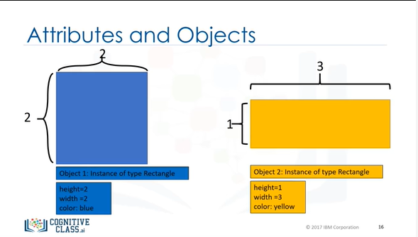

We can also create an object that is an instance of type rectangle.

The color data attribute is blue and the data attribute of height and width is 2.

The second object is also an instance of type rectangle; in this case, the color data attribute is yellow, and the height is one, and the width is three.

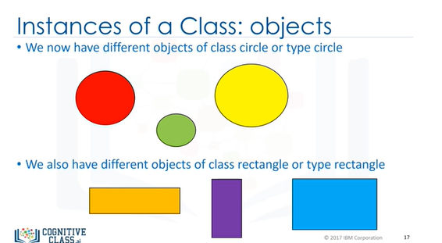

We now have different objects of class circle or type circle.

We also have different objects of class rectangle or type rectangle.

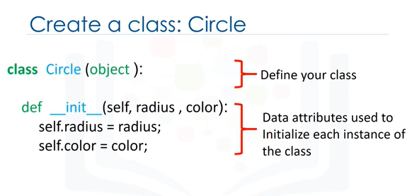

Let us continue building the circle class in Python.

We define our class.

We then initialize each instance of the class with data attributes radius and color using the class constructor.

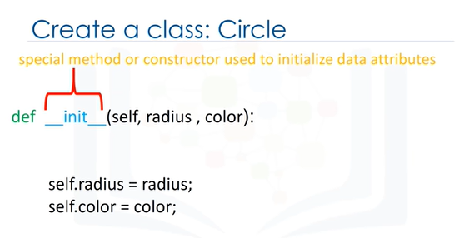

The function "in-it" is a constructor.

It’s a special function that tells Python you are making a new class.

There are other special functions in Python to make more complex classes.

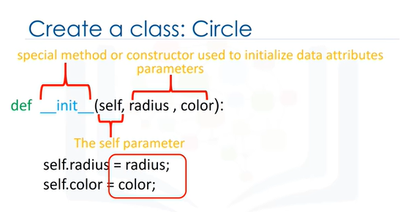

The ‘radius’ and ‘color’ parameters are used to initialize the radius and color data attributes of the class instance.

The ’self’ parameter refers to the newly created instance of the class.

The parameters ’radius’ and ’color’ can be used in the constructor’s body to access the values passed to the class constructor when the class is constructed.

We can set the value of the radius and color data attributes to the values passed to the constructor method.

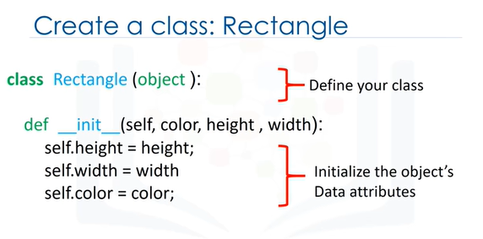

Similarly, we can define the class rectangle in Python.

The name of the class is different.

This time the class data attributes are color, height and width.



After we have created the class, in order to create an object of class circle, we introduce a variable; this will be the name of the object.

We create the object by using the object constructor.

The object constructor consists of the name of the class, as well as the parameters.

These are the data attributes.

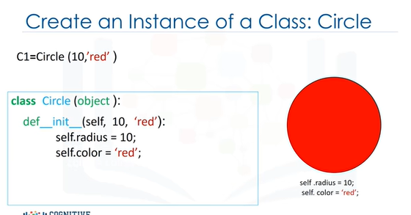

When we create a Circle object we call the code like a function.

The arguments passed to the Circle constructor are used to initialize the data attributes of the newly created Circle instance.

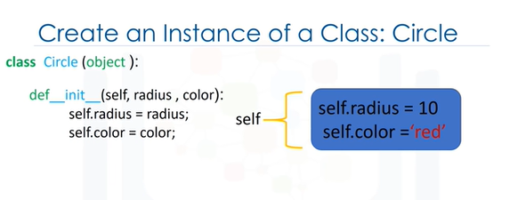

It is helpful to think of self as a box that contains all the data attributes of the object.

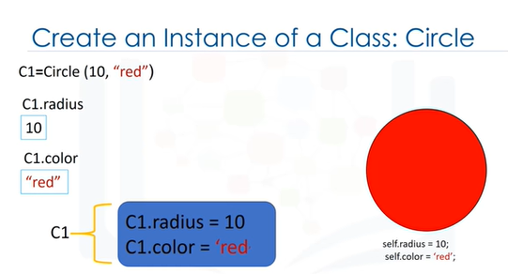

Typing the object's name followed by a dot and the data attribute name gives us the data attribute value, for example radius.

In this case, the radius is ten.

We can do the same for color.

We can see the relationship between the self parameter and the object.

In Python, we can also set or change the data attribute directly.

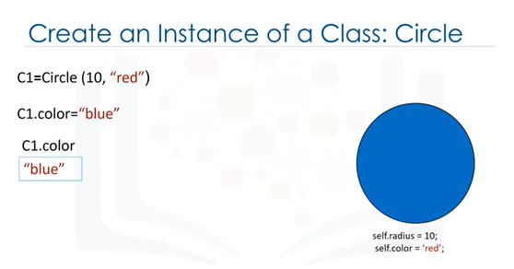

Typing the object's name, followed by a dot and the data attribute name, and set it equal to the corresponding value.

We can verify that the color data attribute has changed.

Usually, in order to change the data in an object we define methods in the class.



Let’s discuss methods.

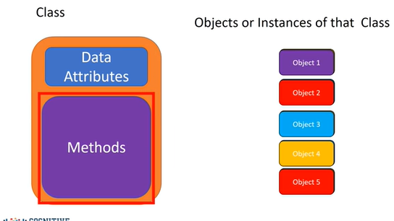

We have seen how data attributes consist of the data defining the objects.

Methods are functions that interact and change the data attributes, changing or using the data attributes of the object.

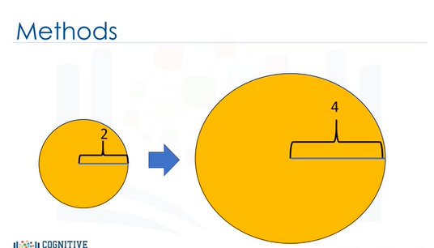

Let's say we would like to change the size of a circle; this involves changing the radius attribute.

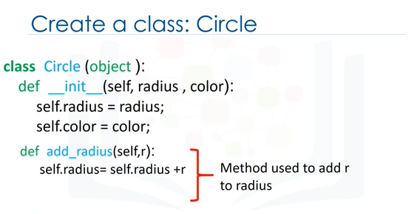

We add a method "add radius" to the class Circle.

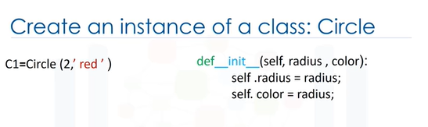

The method is a function that requires the self as well as other parameters.

In this case, we are going to add a value to the radius; we denote that value as r.

We are going to add r to the data attribute radius.

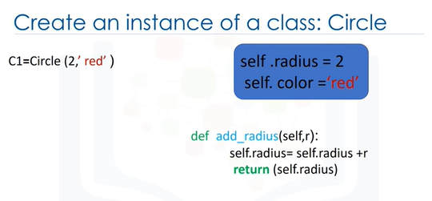

Let's see how this part of the code works when we create an object and call the add radius method.

As before, we create an object with the object constructor.

We pass 2 arguments to the constructor; the radius is set to 2 and the color is set to red.

In the constructor’s body, the data attributes are set.

We can use the box analogy to see the current state of the object.

We call the method by adding a dot followed by the method name and parenthesis.

In this case, the argument of the function is the amount we would like to add.

We do not need to worry about the self-parameter when calling the method—just like with the constructor, Python will take care of that for us.

In many cases, there may not be any parameters (other than self) specified in the method’s definition, so we don’t pass any arguments when calling the function.

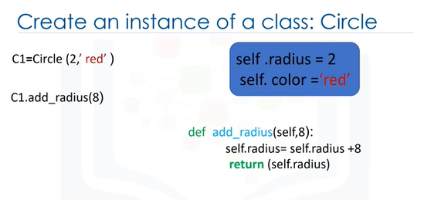

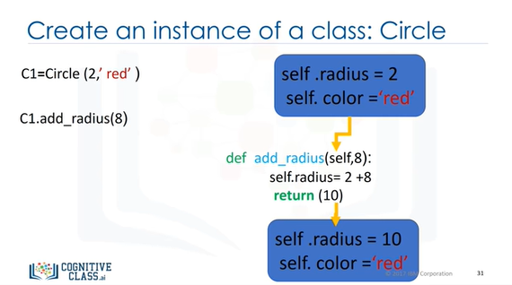

Internally, the method is called with a value of 8 and the proper self object.

The method assigns a new value to self.radius.

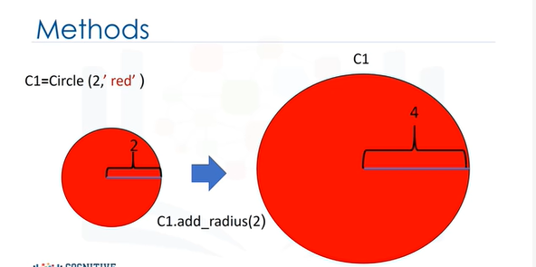

This changes the object; in particular, the radius data attribute.

When we call the add radius method, this changes the object by changing the value of the radius data attribute.

We can add default values to the parameters of a class’s constructor.

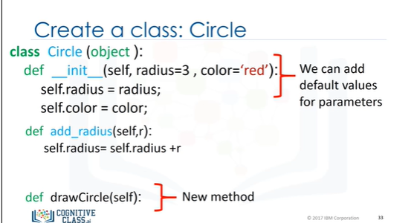

In the labs, we also create the method called "Draw Circle.”

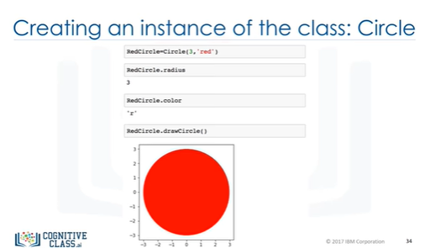

See the lab for the implementation of draw circle.

In the labs, we can create a new object of type Circle using the constructor.

The color will be red and the radius will be 3.

We can access the data attribute radius.

We can access the attribute color.

Finally we can use the method “draw Circle” to draw the circle.

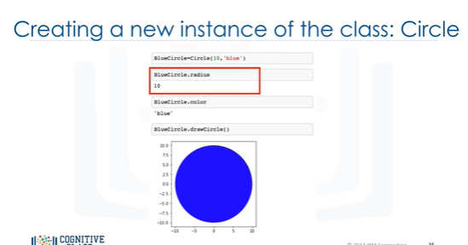

Similarly, we can create a new object of type Circle.

We can access the data attribute of radius.

We can access the data attribute color.

We can use the method “draw circle” to draw the circle.

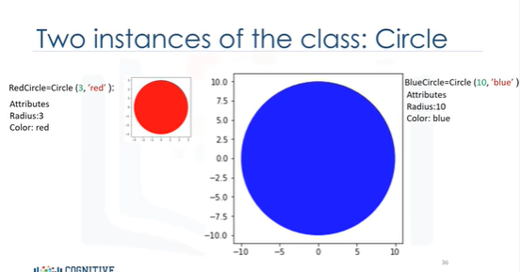

In summary, we have created an object of class Circle called "red circle" with a Radius attribute of 3 and a Color attribute of red.

We also created an object of class Circle called "blue Circle" with a Radius attribute of 10 and a Color attribute of blue.

In the lab, we have a similar class for rectangle.

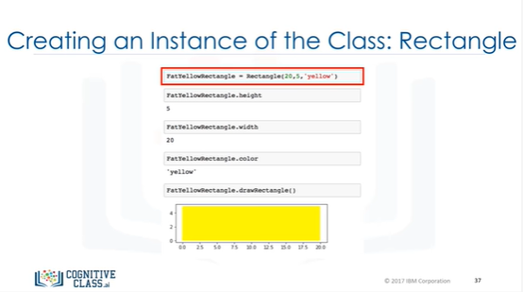

We can create a new object of type rectangle using the constructor.

We can access a data attribute of Height.

We can also access the data attribute of Width.

We can do the same for the data attribute of Color.

We can use the method “draw Rectangle” to draw the rectangle.

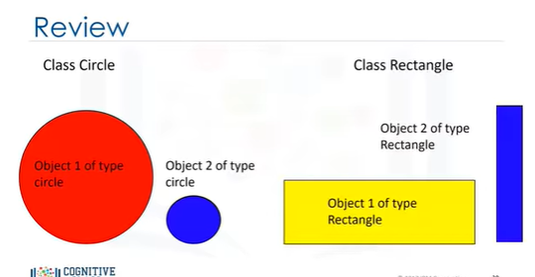

So we have a class, an object that is a realization or instantiation of that class.

For example, we can create two objects of class Circle, or two objects of class Rectangle.

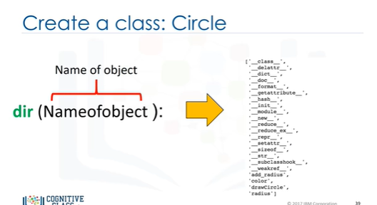

The “D I R” function is useful for obtaining the list of data attributes and methods associated with a class.

The object you’re interested in is passed as an argument.

The return value is a list of that object’s data attributes.

(The attributes surrounded by underscores are for Internal Use and you shouldn’t have to worry about them.)

The regular-looking attributes are the ones you should concern yourself with, these are the object’s methods and data attributes.

There is a lot more you can do with objects in Python.

Check python.org for more info.